Press information

Zumtobel illuminates Montforthaus with a unique new LED lighting solution
In close cooperation with the lighting design firm BELZNER HOLMES / LIGHT DESIGN ENGINEERING, Zumtobel has developed a bespoke LED solution for Montforthaus that meets stringent television requirements by combining seamless dimming between 100 and 0 percent with a colour temperature range from 2700K to 5000K - a feat that had previously proved impossible in the field of architectural lighting.
Dornbirn, April 2015 – Montforthaus brings art and culture together under one roof by hosting events including concerts, fairs, congresses and symposiums. The new multifunctional venue in the Austrian town of Feldkirch is the result of a competition organised by the local authorities and replaces the original Montforthaus building. The culture and congress centre was officially opened in January 2015 after five years of planning and construction. The building is characterised by striking structural contours and a flowing design language crafted in the Berlin office of HASCHER JEHLE Architektur. Transparent facades and a glass dome in the foyer of the organically shaped building help fuse the interior and exterior elements of the project. This enables daylight to penetrate the Great Hall, the heart of the building, which stands boldly like a wooden musical instrument in the middle of the foyer area.
This architectural principle of permeability was also central to the lighting concept, devised by the dedicated architectural and stage lighting design office of BELZNER HOLMES / LIGHT DESIGN ENGINEERING (LDE) and realised in close cooperation with Zumtobel. Daylight had to be able to pass through the large glass surfaces and be dispersed throughout the building to create a uniform natural lighting effect. However, to meet the high demands of this multifunctional application, it was also necessary to consider a series of further issues. LDE were tasked with designing a flexible lighting concept that could be adapted for different functions. This meant finding a way of being able to create the desired mood for events ranging from stylish receptions to breath-taking concerts and academic symposiums. To highlight the design language of the building, a discrete lighting solution was required to accentuate the flowing and contoured lines of the distinctive architecture. Diverging ceiling heights of between 2.4 and 10 metres also had to be taken into account. It was clear that a highly sophisticated lighting solution would be necessary to perform this delicate balancing act.
Following an extensive testing and exploratory phase, the decision was taken to use a bespoke lighting solution from Zumtobel. The overwhelmingly positive experience that LDE architect and lighting designer Prof. Uwe Belzner and his team had enjoyed with Zumtobel in the past and the considerable knowledge and technological expertise of the Vorarlberg-based lighting solution specialists were decisive factors. The core objective of ​​the lighting solution was to achieve flicker-free LED lighting that could be dimmed right down to 0 percent. This would enable TV broadcasts in High Definition (HD) quality to be made from Montforthaus. Based on an existing Zumtobel technology that facilitates the flexible mixing of cold white or warm white light sources, the LDE offices in Stuttgart and Liechtenstein worked closely with Zumtobel to devise a custom-made solution for this project. The starting point for the new development was PANOS infinity. The design and construction of this celebrated modular LED downlight range means that it could be installed throughout the different areas of the building. The PANOS infinity family blends the sophisticated design of Sottsass Associati and the advanced technological functionality synonymous with Zumtobel engineering. In addition, excellent energy efficiency and extra-long maintenance intervals deliver tangible cost savings and help protect the environment.
Stepless dimming from 100 to 0 percent makes the unique MFH-PANOS solution a world first in the field of architectural lighting. In stark contrast to previous products, the MFH-PANOS solution harnesses specially developed Zumtobel technology to achieve a smooth and flicker-free transition for the first time ever in the range from 10 to 0 percent. Extensive testing in the studios of Austrian television broadcaster ORF confirmed the high quality of this innovation. A series of experimental HD recordings were made without any flickering or visual disturbance. The colour temperature of MFH-PANOS can be fully adjusted from warm white to cold white to suit any occasion. The ratio of warm and cold white light can be controlled individually using separate DMX or DALI control channels. Depending on the necessary response rate, the integrated 28W, 30W or 40W downlights are equipped with intelligent DALI or DMX technology that enables the separate control of each luminaire. Optimal thermal management helps guarantee optimal energy efficiency, as special cooling features guarantee maximum light yield and thereby minimise energy consumption. Individually manufactured ring attachments in predefined RAL colours ensure seamless integration into the interior architecture.
"With the special solution for Montforthaus, we have developed a luminaire that is truly unique. The MFH-PANOS has been designed specifically to meet the needs of our customer, but the potential for global success is already clear," explained Philippe Rettenbacher, project manager from Zumtobel.
A total of 18 different Zumtobel products are present in Montforthaus, including LIGHTFIELDS evolution in the stairwell, ONDARIA in the café and CRAFT as general lighting for the stage area. Altogether more than 2,500 Zumtobel luminaires were required, including around 750 pieces of the different MFH-PANOS variants. As well as the development of this special solution, Zumtobel offered a level of project support and attention to detail that came to characterise the close cooperation between all stakeholders.
Photo captions:
(Photo credits: Zumtobel)
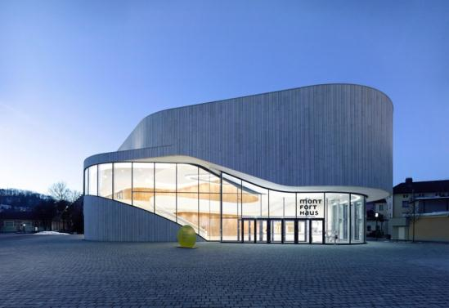
Photo 1: Standing in the shadow of the historic Schattenburg castle, the organic contours of Montforthaus blend seamlessly with the old town of Feldkirch.
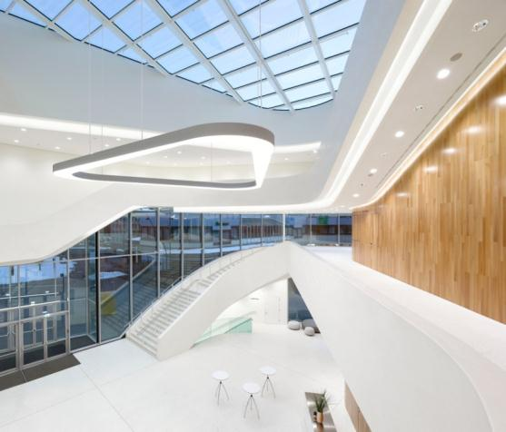
Photo 2: Different ceiling heights and abundant natural daylight in the foyer area of Montforthaus placed specific demands on the Zumtobel lighting solution.

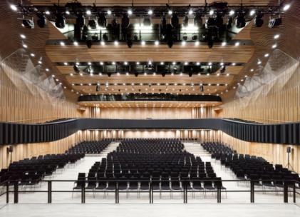
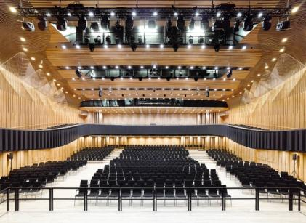
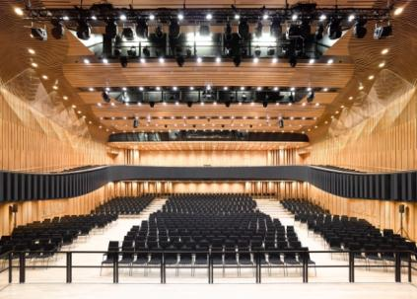
Photo 3: Individual control of the lighting scenarios in areas like the Great Hall helps create the perfect atmosphere for every event and every occasion (cool white, neutral white and warm white).
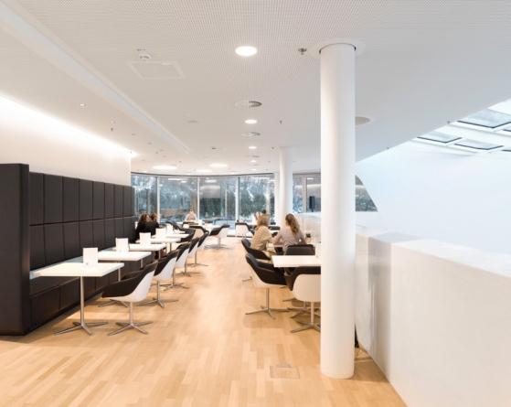
Photo 4: A combination of the special MFH-PANOS solution and ONDARIA set the scene in the Monforthaus café.

Press contact:
Zumtobel Lighting GmbH
Sophie Moser
PR Manager
Schweizer Strasse 30
A-6850 Dornbirn

Tel +43-5572-390-26527
Mobil +43-664-80892-3074
E-Mail press@zumtobel.com
www.zumtobel.com

Sales contact:
Zumtobel Lighting Ltd.  Chiltern Park  Chiltern Hill, Chalfont St Peter  Buckinghamshire SL9 9FG  United Kingdom  Tel: +44 1753 482 650  Fax: +44 1753 480 350  uksales@zumtobel.com  www.zumtobel.co.uk | Zumtobel Lighting Inc.  3300 Route 9  Highland , NY 12528  United States  Tel: +1 845 691-6262  Fax: +1 845 691-6289  zli.us@zumtobelgroup.com  www.zumtobel.us

For further contact details in further sales regions please visit: http://www.zumtobel.com/com-en/contact.html

About Zumtobel
Zumtobel, a leading international supplier of integral lighting solutions, enables people to experience the interplay of light and architecture. As a leader in innovation, Zumtobel provides a comprehensive range of high-quality luminaires and lighting management systems for professional interior lighting in the areas of offices, education, presentation & retail, hotel & wellness, health, art & culture as well as industry. Zumtobel is a brand of Zumtobel AG with its head office in Dornbirn, Vorarlberg (Austria).
Zumtobel. The Light.

