Press release

Two iF DESIGN AWARDS won by Zumtobel
Zumtobel's design competence has been acknowledged once again: two products, the SEQUENCE and INTRO LED luminaires, have been awarded the coveted iF DESIGN AWARD 2015, on account of their outstanding product design and efficient lighting technology.
Dornbirn, February 2015 – The jury of the internationally renowned iF DESIGN AWARD has paid tribute to the superior design and lighting quality of the SEQUENCE LED luminaire and the INTRO LED spotlight system by conferring to each of them an iF DESIGN AWARD in the product design category. Late in January, 53 jurors from 20 countries met in Hamburg to evaluate 4783 entries from all over the world. Zumtobel won its first design award in 1961; hence, the company can now look back to a total of 78 iF DESIGN AWARDS. This makes Zumtobel one of the most successful B2B companies in terms of design competence.
“Architectural design is a fundamental aspect of our brand philosophy. We are proud to have been awarded prizes for our product design once again this year. The iF DESIGN AWARD confirms our ambitions to develop innovative lighting solutions with high aesthetic appeal and added value for our customers,” says Stefan von Terzi, Marketing Director Zumtobel. The awards will be presented on 27 February 2015 at the BMW World in Munich, in the presence of some 2000 guests from international design circles, the media, business and politics.
These are the award-winning products:
SEQUENCE: LED luminaire for individual task lighting
The SEQUENCE LED luminaire meets varied requirements of employees with respect to ideal office lighting as well as the need for customisation to the utmost degree. Thanks to LED technology and the miniaturisation of light sources associated with it, the sophisticated luminaire unit requires only 25 mm in height and blends perfectly into any interior design. SEQUENCE is available as a pendant and surface-mounted luminaire and cannot fail to impress on account of its cutting-edge innovative system design consisting of LED modules that can be individually controlled. SEQUENCE provides a perfect combination of direct and indirect lighting. The development of the special advancedOptics lens technology has made it possible to perfectly combine the demands for large quantities of light and maximum glare control.
INTRO: modular LED lighting system with innovative reflector technology
The INTRO lighting system offers retailers an efficient lighting solution that can be fully customised to cater for various areas of a store in one and the same design: from shop windows, shelves and recesses through to promotional spaces. The modular lighting system combines various types of luminaires that use the very latest LED technology. The system is based on spotlight modules that can be aligned flexibly and even be combined in various light colours or beam angles, depending on requirements. With the development of liteCarve® reflector technology, INTRO has created a new product category: a spotlight for vertical, right-angle surfaces. This innovation is based on the freeform reflector (patent pending) which allows extremely precise, well-balanced rectangular light distribution, right up to the outermost peripheries. Accordingly, displays, shelves, large posters, recesses or special wall areas can be illuminated uniformly and efficiently.
About the iF DESIGN AWARD
The iF DESIGN AWARDS were introduced in 1953 and rank among the most important design awards world-wide. Winners are chosen by independent juries comprising internationally renowned designers, businessmen and scientists according to specific pre-defined criteria. Each year, the best designs of innovative companies are given awards in various categories. The awards are conferred in five categories: Product, Communication and Packaging Design as well as Interior Architecture and Professional Concepts. The iF DESIGN AWARD is considered an indicator of future-oriented design trends and product innovations.
Captions:
(Photo credits: Zumtobel)
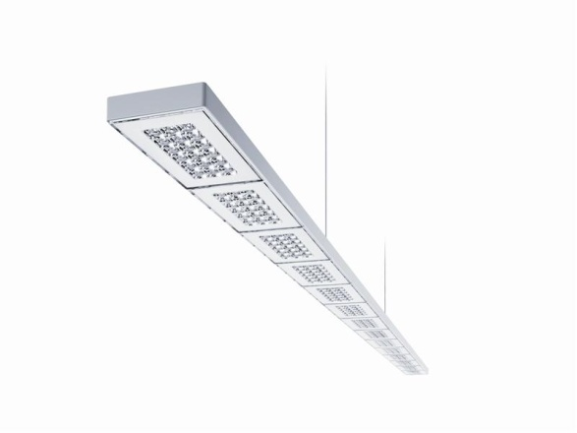
Fig. 1: The SEQUENCE LED luminaire redefines established design conventions and breaks new ground in terms of technology and aesthetics.
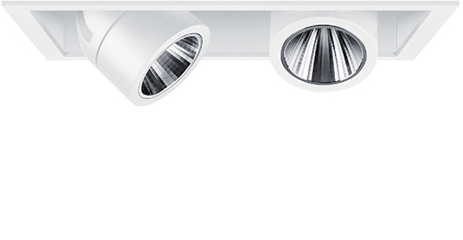
Fig. 2: Zumtobel's modular INTRO system is available in single, double and triple units, and also as a lighting channel. All spotlight modules can be fitted with different front ring versions that are supplied in white, black, matt silver, chrome and copper, as required. There are virtually infinite customisation options.
Fig. 3: Stefan von Terzi, Zumtobel Marketing Director

Press contact:
Zumtobel Lighting GmbH
Sophie Moser
PR Manager
Schweizer Strasse 30
A-6850 Dornbirn

Tel +43-5572-390-26527
Mobil +43-664-80892-3074
E-Mail press@zumtobel.com
www.zumtobel.com

Sales contact:
Zumtobel Lighting Ltd.  Chiltern Park  Chiltern Hill, Chalfont St Peter  Buckinghamshire SL9 9FG  United Kingdom  Tel: +44 1753 482 650  Fax: +44 1753 480 350  uksales@zumtobel.com  www.zumtobel.co.uk | Zumtobel Lighting Inc.  3300 Route 9  Highland , NY 12528  United States  Tel: +1 845 691-6262  Fax: +1 845 691-6289  zli.us@zumtobelgroup.com  www.zumtobel.us

For further contact details in further sales regions please visit: http://www.zumtobel.com/com-en/contact.html

About Zumtobel
Zumtobel, a leading international supplier of integral lighting solutions, enables people to experience the interplay of light and architecture. As a leader in innovation, Zumtobel provides a comprehensive range of high-quality luminaires and lighting management systems for professional interior lighting in the areas of offices, education, presentation & retail, hotel & wellness, health, art & culture as well as industry. Zumtobel is a brand of Zumtobel AG with its head office in Dornbirn, Vorarlberg (Austria).
Zumtobel. The Light.

