Press information

A rich series of design success
SEQUENCE claims "Red Dot: Best of the Best" award
The SEQUENCE, AXON and INTRO LED luminaires have helped Zumtobel add to their impressive haul of international design awards. A brilliant combination of design and lighting quality has seen SEQUENCE win a coveted "Red Dot: Best of the Best" award as the leading product in the light and luminaire category.
Dornbirn, June 2015 – With a keen eye for good design and genuine innovation, the Red Dot jury selected the SEQUENCE LED pendant and surface luminaire as a worthy recipient of the "Red Dot: Best of the Best" title. In addition, the INTRO LED spotlight system and AXON LED pendant luminaire have both received Red Dot product design awards for their outstanding design quality.
The starting point for the design and development of SEQUENCE were the findings of a recent study into the needs of people in a modern working environment. Free from the constraints of existing concepts, Zumtobel has engineered a luminaire that opens up new dimensions in terms of flexibility and adaptability to meet specific individual requirements. A fine blend of elegant design and subtle materials sets SEQUENCE apart from traditional office lighting solutions. "Zumtobel stands for design quality and applied innovation. The individual needs of the user are always at the centre of everything we do. SEQUENCE is a prime example of this approach. We are delighted that our hard work has been recognised with a Red Dot: Best of the Best award," explained Stefan von Terzi, Zumtobel Marketing Director.
The Red Dot Gala will take place in the Aalto Theatre in the German town of Essen on 29. June 2015. As a winner of the Red Dot: Best of the Best award, Zumtobel will be given the honour of collecting the prize on stage in the presence of more than 1200 international guests from the world of design, media, business and politics.
The winning products at a glance
SEQUENCE: The LED pendant and surface luminaire SEQUENCE compromises of separately controlled LED modules that enable maximum freedom to configure individual workplace lighting. Cutting-edge LED technology and the associated reduction in the size of the light source paved the way for a sleek housing that measures just 25mm in height and blends perfectly with any interior architecture. SEQUENCE boasts a prime mix of direct and indirect lighting. With the development of special advancedOptics lens technology, it is possible to deliver high light levels with optimal glare control.
INTRO: The modular LED system offers retailers an efficient and highly adaptable lighting solution with a uniform design for a variety of different areas, ranging from shop windows to shelves and general retail zones. Adjustable spotlights form the basis of the system and these can be specified with a range of different colour temperatures and beam characteristics to suit the requirements of any application. The development of liteCarve® reflector technology has helped INTRO establish a completely new product category - a spotlight for vertical rectangular surfaces. The highly innovative patent-pending free-form reflector breaks new ground with the delivery of a precise and well-balanced rectangular light distribution, even in the peripheral areas.
AXON: The LED pendant luminaire cannot fail to impresses with its slim square design. The elegant housing redefines the conventional limits of compact office solutions thanks to a cross-section measuring just 38 x 38mm. Despite this miniaturised form, maximum effectiveness and efficiency are still very much guaranteed. The indirect/direct light distribution harnesses the innovative advancedOptics lens technology, which balances high lumen packages, excellent glare control and low luminance levels. Efficient illumination of workspaces can be combined with a pleasant uniform lighting effect on the ceiling courtesy of a wide-angle indirect optic.

Photo captions:

(Photo credits: Zumtobel)
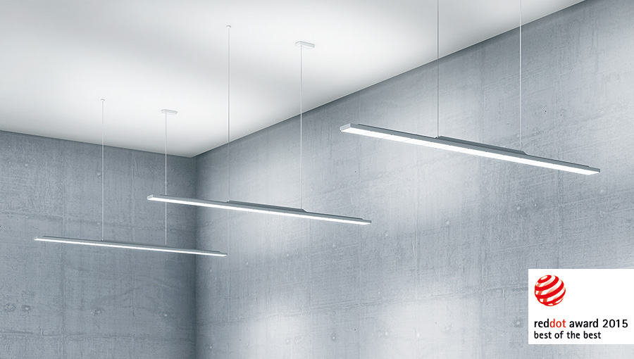
Photo 1: SEQUENCE claims a coveted "Red Dot: Best of the Best" award as the leading product in the light and luminaire category.

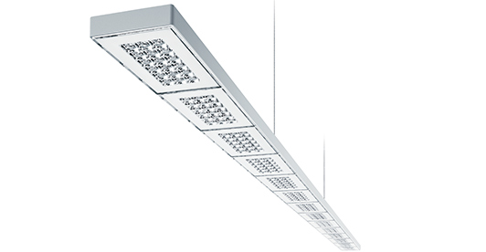
Photo 2: Cutting-edge LED technology creates office lighting with optimal glare control, offering the user maximum visual comfort.
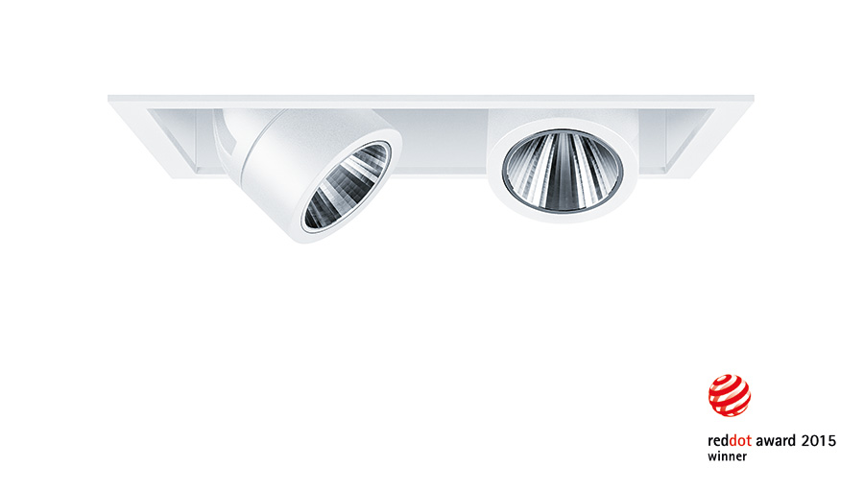
Photo 3: The INTRO retail spotlight system receives a Red Dot award 2015. 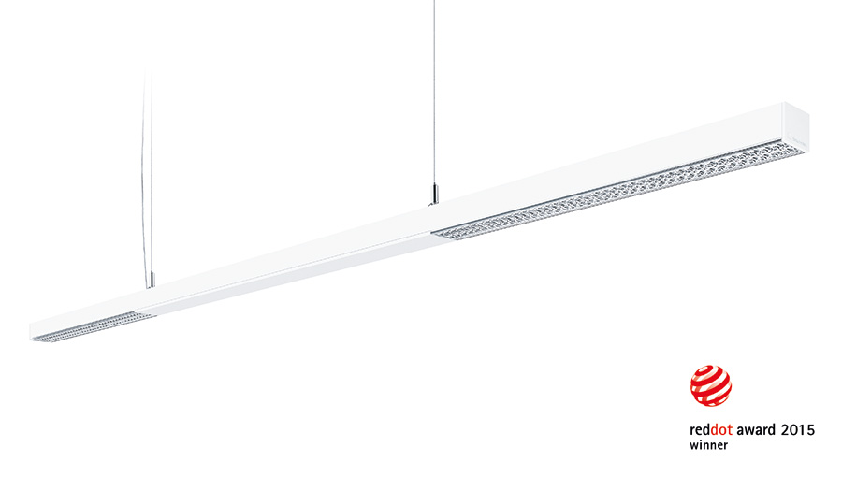
Photo 4: The unparalleled AXON slim indirect/direct luminaire, delivering high efficiency and the visual comfort of an office lighting solution with good glare control, also picks up a Red Dot award 2015.
Photo 5: Stefan von Terzi, Marketing Director Zumtobel
Press contact:
Zumtobel Lighting GmbH
Sophie Moser
Head of Brand Communications
Schweizer Strasse 30
6850 Dornbirn
Austria

Tel: +43 5572 390 26527
Mobil: +43 664 80892 3074
press@zumtobel.com

www.zumtobel.com

Sales contact:
Zumtobel Lighting Ltd.  Chiltern Park  Chiltern Hill, Chalfont St Peter  Buckinghamshire SL9 9FG  United Kingdom  Tel: +44 1753 482 650  Fax: +44 1753 480 350  uksales@zumtobel.com  www.zumtobel.co.uk | Zumtobel Lighting Inc.  3300 Route 9  Highland , NY 12528  United States  Tel: +1 845 691 6262  Fax: +1 845 691 6289  zli.us@zumtobelgroup.com  www.zumtobel.us

For further contact details in further sales regions please visit: http://www.zumtobel.com/com-en/contact.html

About Zumtobel
Zumtobel, a leading international supplier of integral lighting solutions, enables people to experience the interplay of light and architecture. As a leader in innovation, Zumtobel provides a comprehensive range of high-quality luminaires and lighting management systems for professional interior lighting in the areas of offices, education, presentation & retail, hotel & wellness, health, art & culture as well as industry. Zumtobel is a brand of Zumtobel Group AG with its head office in Dornbirn, Vorarlberg (Austria).
Zumtobel. The Light.

