Press release

SUPERSYSTEM outdoor: the future of outdoor lighting
Zumtobel's SUPERSYSTEM outdoor LED solution uses a completely innovative approach in illuminating paths, squares, roads and façades for specific purposes. Targeted space-defining illumination of outdoor areas is now also possible thanks to lighting modules featuring various beam patterns based on the SUPERSYSTEM modular system for interior lighting.
Dornbirn, November 2015 – Creating identity, providing orientation and presenting buildings to optimum effect: today, the tasks performed by contemporary LED outdoor lighting go far beyond the conventional illumination of roads, squares and façades. Rather they enhance complex spatial structures and varied buildings, increase a region's recognition value and provide orientation also in the dark. With SUPERSYSTEM outdoor, Zumtobel has developed a new LED luminaire range that meets these requirements to the greatest possible extent and provides space-defining LED accent lighting for outdoor areas.
SUPERSYSTEM outdoor is based on the versatile interior lighting system of the same name, and is highly flexible thanks to its minimalist design language and ultra-compatible modular system allowing to assemble the individual modules as required. This flexibility allows to provide outdoor illumination creating an individual appearance. In addition to a variety of columns and fixing options for illuminating roads, squares, façades and trees, the system boasts extremely flexible luminaire heads. The luminaires can be configured with 6 to 34 LED tubes featuring the most diverse beam patterns. Each LED tube can be aligned with high precision towards the object to be illuminated. Thus, depending on the object and distance to be covered, narrow-beam, wide-angle or asymmetrical light distribution can be provided. This allows emission of light in a considerably more precise and targeted way than is possible with other outdoor luminaires, and to precisely adjust it to the lighting tasks at hand. Thus, SUPERSYSTEM outdoor is able not only to illuminate horizontal roads, squares or paths, but also to brighten up vertical areas uniformly. Thanks to the varied angles of the individual LED tubes, glare produced by the luminaire is also extremely reduced. Colour perception is ensured as well thanks to a good colour rendering index. In addition, luminaire versions with a colour temperature of 3000 K and 4000 K are ideal for presenting both a city's historic centre and a modern skyline in the right light. Instead of installing the luminaire heads on the columns, they can also be installed on the façades, thus not only providing for uniformity of appearance but also for spectacular illumination of hotel façades.
SUPERSYSTEM outdoor has been developed out of the lighting solution designed for the new town lighting of the tourist resort of Lech am Arlberg in Austria. Dieter Bartenbach has developed an LED lighting concept for the ski resort aiming at flexible illumination of vertical and horizontal room structures, which not only allows proper ambient lighting but also makes spatial depths perceptible, simultaneously reducing the number of luminaires and energy consumption to a minimum. The concept was implemented by Dieter Bartenbach in collaboration with Zumtobel. The lighting experts came up with a special luminaire especially manufactured for this purpose, whose luminance is divided among several LED tubes with varying beam patterns, ensuring that passers-by are barely distracted by glare. Another benefit is the system's modular design: the luminaires can be configured with 6 to 34 LED tubes, each with approx. 2 W. Thus, the lighting situation can be adjusted as required. Depending on the location, Zumtobel has also developed various versions to be installed on columns and façades as well as for illumination of the river Lech. Thus, one single luminaire range is able to perform nearly all outdoor lighting tasks in the town of Lech.
SUPERSYSTEM outdoor facts & figures
- For outdoor applications
- Modules incorporating 6 to 34 LED tubes
- To be installed on façades, walls or columns
- Choice of colour temperatures: 3000 K and 4000 K
- Installed load: 2 W
- Good colour rendering
- Service life: 50,000 hours

Captions:

(Photo credits: Zumtobel)

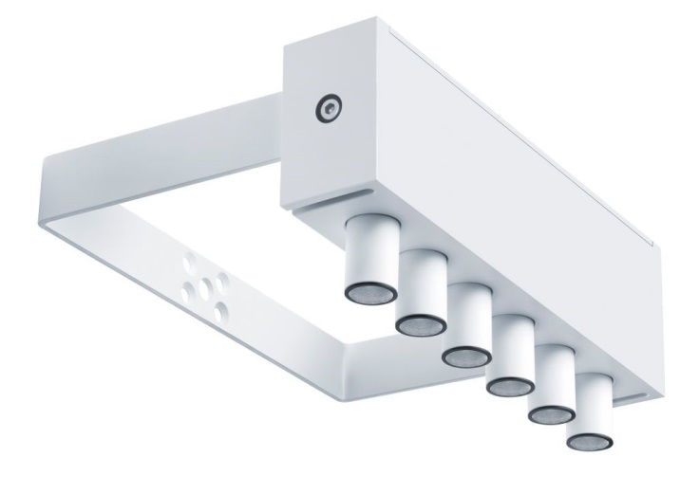

Fig. 1: Zumtobel's SUPERSYSTEM outdoor LED solution uses a completely innovative approach in illuminating paths, squares, roads and façades for specific purposes.

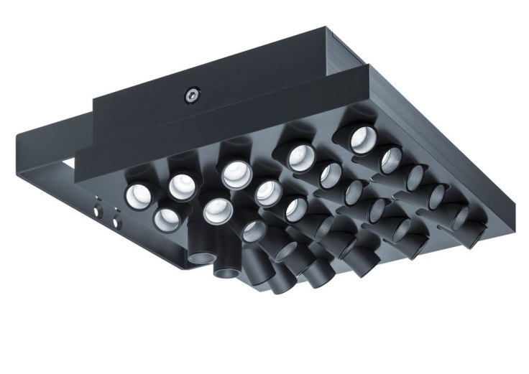

Fig. 2: The luminaires can be configured in modules with 6 to 34 LED tubes featuring the most diverse beam patterns.

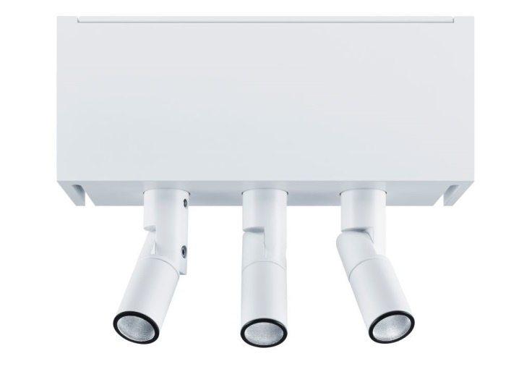

Fig. 3: Luminaire versions with a colour temperature of 3000 K and 4000 K are ideal for presenting both a city's historic centre and a modern skyline in the right light.

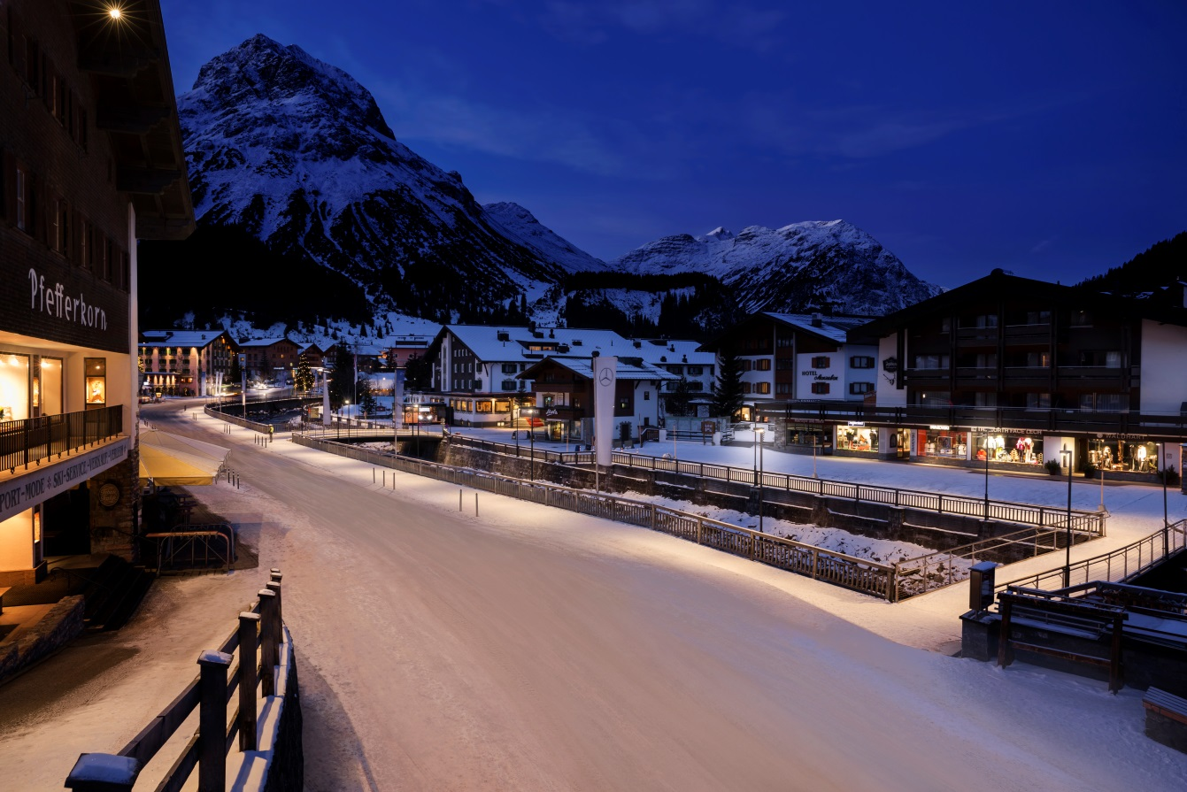
Fig. 4: With SUPERSYSTEM outdoor, Zumtobel has developed a new LED luminaire range that provides space-defining LED accent lighting for outdoor areas.
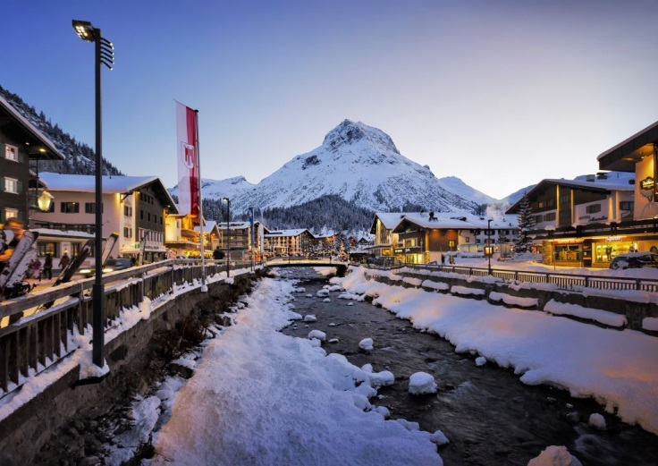
Fig. 5: The town of Lech am Arlberg shines in a new light.

Press contact:
Zumtobel Lighting GmbH
Sophie Moser
Head of Brand Communications
Schweizer Strasse 30
6850 Dornbirn
Austria

Tel: +43 5572 390 26527
Mobil: +43 664 80892 3074
press@zumtobel.com

www.zumtobel.com

Sales contact:
Zumtobel Lighting Ltd.  Chiltern Park  Chiltern Hill, Chalfont St Peter  Buckinghamshire SL9 9FG  United Kingdom  Tel: +44 1753 482 650  Fax: +44 1753 480 350  uksales@zumtobel.com  www.zumtobel.co.uk | Zumtobel Lighting Inc.  3300 Route 9  Highland , NY 12528  United States  Tel: +1 845 691 6262  Fax: +1 845 691 6289  zli.us@zumtobelgroup.com  www.zumtobel.us

For further contact details in further sales regions please visit: http://www.zumtobel.com/com-en/contact.html

About Zumtobel
Zumtobel, a leading international supplier of integral lighting solutions, enables people to experience the interplay of light and architecture. As a leader in innovation, Zumtobel provides a comprehensive range of high-quality luminaires and lighting management systems for professional interior lighting in the areas of offices, education, presentation & retail, hotel & wellness, health, art & culture as well as industry. Zumtobel is a brand of the Zumtobel Group AG with its head office in Dornbirn, Vorarlberg (Austria).
Zumtobel. The Light.

