Press information

Maximum effect from a minimalist lighting solution
Zumtobel uses SUPERSYSTEM outdoor to support effective design and uniform illumination at the new Sägerbrücke bridge in Dornbirn.
Dornbirn, June 2016 – The comprehensive renovation of the Dornbirn Stadtstrasse (city street) from the Kronenkreuzung (crown junction) to the Sägerstrasse (sawyer street) and the new construction of the Sägerbrücke bridge represent a pioneering engineering project. The new Sägerbrücke bridge not only caters for different needs and interests, but also represents an architectural highlight by helping art become an integral part of the public space. The lighting solution for the bridge was developed and realised by Zumtobel in close cooperation with the architect Hugo Dworzak, the city planner Stefan Burtscher and the artist Hubert Lampert, who has crafted a truly eye-catching element in the middle of the bridge with the “Do.Helix” installation.
In terms of pure functionally the Sägerbrücke bridge offers a crossing over the Dornbirner Ach river, but it is also a key point for cars and lorries accessing the downtown area and a busy hub for public transport. For this reason it was necessary to create space for an intelligent traffic management solution to increase the quality of the daily experience for around 1600 urban and regional bus users and to improve safety for cyclists and pedestrians. With a width of 37.5 metres and a length of 32.5 metres, the bridge is actually wider than it is long. Four lanes of traffic are flanked on each side by a 7.5-metre-wide section that incorporates a pedestrian walkway, a bike lane and a waiting area for bus users.
The key challenge for the lighting solution was to ensure a uniform illumination that covered the total area and complied fully with the relevant standards for road transport, cycle paths and pedestrian crossings, despite only having two luminaire mounting positions to work with – one at each end of the bridge. Zumtobel impressed the architect, the artist Hubert Lampert and those responsible for the city planning with a pair of 13-metre-high masts for the customised SUPERSYSTEM outdoor LED luminaire, along with the linear, restrained design language of the product itself, which integrated discreetly into the overall architectural concept.
One of the major advantages of LED technology is the greater design freedom enabled by the compact size of the components. Each mast measures just 300mm by 300mm and yet still has room to incorporate 13 luminaires, with each luminaire made up of 18 LED light tubes. By grouping six LED light tubes and directing these towards a specific part of the bridge, it was possible to achieve a completely uniform illumination of the entire surface and maximum visual comfort without causing glare for users crossing the bridge.
The Sägerbrücke bridge uses a neutral white colour temperature of 4000 K, in line with the standards specified by the local authorities, to deliberately stand out from its surroundings and to highlight the square-like opening into the downtown area. The low connected load of just 43W for each luminaire (560W for each lighting mast) and the precise light distribution, which helps avoid unnecessary light pollution, mean that SUPERSYSTEM outdoor also represents an extremely energy-efficient choice. The minimalist design language of the product delivers high visual quality without taking centre stage, so that both the architecture of the “island bridge” and the sculpture in the centre can be fully appreciated.
Photo captions:
(Photo credits: Zumtobel)
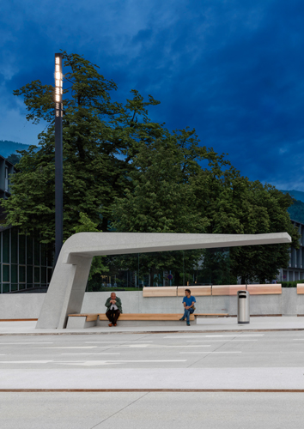
Photo 1: Zumtobel impressed the architect, and those responsible for the city planning with the customised SUPERSYSTEM outdoor LED luminaire.
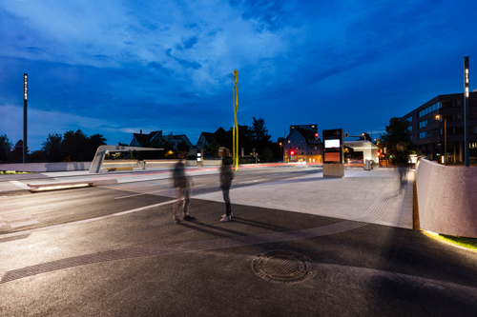
Photo 2: The minimalist design language of the product delivers high visual quality without taking centre stage, so that both the architecture of the “island bridge” and the sculpture in the centre can be fully appreciated.
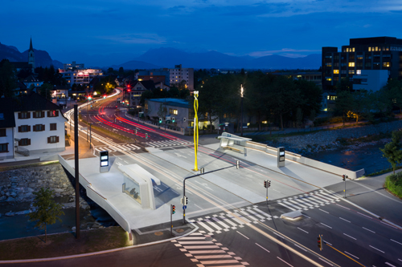
Photo 3: The key challenge for the lighting solution was to ensure a uniform illumination that covered the total area and complied fully with the relevant standards for road transport, cycle paths and pedestrian crossings.

Press contact:
Zumtobel Lighting GmbH
Andreas Reimann
Brand PR Manager
Schweizer Strasse 30
A-6850 Dornbirn

Tel: +43 5572 390 26522
Mobil: +43 664 80892 3334
press.zumtobel@zumtobelgroup.com
www.zumtobel.com

About Zumtobel
As a leader in innovation, Zumtobel develops sustainable lighting solutions tailored to the needs of people in their respective applications. With a comprehensive portfolio of high-quality luminaires and intelligent lighting management systems, the Austrian company provides optimum indoor and exterior products for working and living spaces - the right light for every activity at any time of day. The applications office, education, presentation and retail, hotel and wellness, health, art and culture and industry are now perfectly complemented with portfolios for living and outdoor areas. Zumtobel is a brand of Zumtobel Group AG with its head office in Dornbirn, Vorarlberg (Austria).
Zumtobel. The Light.

