Press Release

Green Good Design Award 2016 for MIREL LED
New generation of luminaire wins special prize for sustainable design

Maximum energy efficiency, excellent light quality and all-purpose design: The MIREL LED louvre luminaire (US version) by Zumtobel is a prime example of the lighting of the future and was therefore awarded the "Green Good Design Award 2016".

Dornbirn, June 2016 – Zumtobel achieves the highest international recognition from the USA: The advanced development of the louvre luminaire MIREL LED (US version) has been awarded the "Green Good Design Award 2016" from the Chicago Athenaeum, Museum of Architecture and Design. The renowned "Good Design Award" special prize is awarded for innovative products that have an especially sustainable design and to the companies behind them for their commitment to the environment.
"The topic of sustainability is inextricably linked to our brand image", says Nikolaus Johannson, Director Marketing Americas at the Zumtobel Group. "The Green Good Design Award 2016" rewards our efforts in developing innovative lighting concepts, which are characterised by environmental compatibility and a high-level of added value. Once again, the MIREL LED has proven this recipe for success to be true: The high light efficiency and superb light quality makes the all-purpose luminaire one of the most distinguished future-orientated lighting solutions".
The MIREL LED was developed together with the product design office STUDIO AMBROZUS from Cologne and is the latest generation of the successful MIREL product group. Its exceptional light quality is based on special lens optics for targeted bat wing light distribution. This makes for ideal workplace lighting and a brilliant appearance without any irritating glare. In combination with a high light efficiency of 119 lm/W and a clear, subtle style, the MIREL LED is particularly suitable for versatile visual tasks in the offices and education area of application.
The "Good Design Award" was launched in 1950 by architects Eero Saarinen, Ray and Charles Eames and MoMa curator Edgar Kaufmann Jr. and since then has been awarded by the Chicago Athenaeum, Museum of Architecture and Design and the European Centre for Architecture Art Design and Urban Studies. The "Good Design Award" is deemed to be the acknowledged international hallmark for high-quality products that are characterised by innovative design, outstanding quality and a high-level of functionality.

Image captions:

(Photo Credits: Zumtobel)
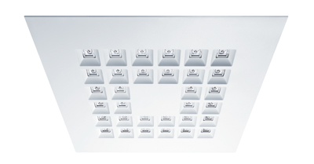
Bild 1: The MIREL LED louvre luminaire by Zumtobel is a prime example of the lighting of the future and was therefore awarded the "Green Good Design Award 2016".
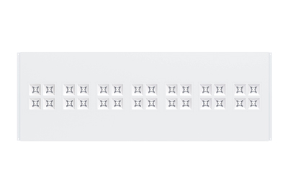
Bild 2: The MIREL LED was developed with the product design office STUDIO AMBROZUS from Cologne and is the latest generation of the successful MIREL product group.

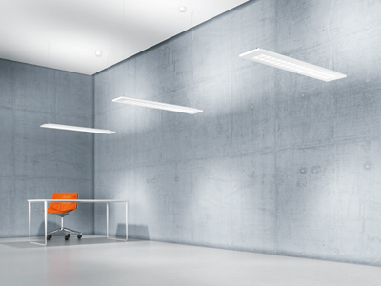
Bild 3: Its exceptional light quality is based on special lens optics for targeted bat wing light distribution.
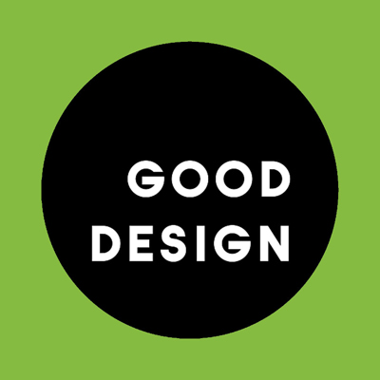
Bild 3: Official Logo: Green Good Design Award 2016.

Pressekontakt:
Zumtobel Lighting GmbH  Andreas Reimann  Brand PR Manager  Schweizer Strasse 30  6850 Dornbirn  Austria  Phone: +43 5572 390 26522  press.zumtobel@zumtobelgroup.com  www.zumtobel.com | Zumtobel Group  Jennifer Sewell  Marketing Communications Manager  Chiltern Park, Chiltern Hill  Chalfont St Peter, Buckinghamshire SL9 9FG  United Kingdom  Phone: +44 0 7785 232 294  jennifer.sewell@zumtobelgroup.com  www.zumtobel.com
Zumtobel Lighting Inc.
Karianna Haasch
Marketing Manager Americas
Zumtobel Lighting US
3300 Route 9W
Highland, NY 12528
Phone: +1 845-691-6262 - 7611
donna.fischer@zumtobelgroup.com
www.zumtobel.us

About Zumtobel
As a leader in innovation, Zumtobel develops sustainable lighting solutions tailored to the needs of people in their respective applications. With a comprehensive portfolio of high-quality luminaires and intelligent lighting management systems, the Austrian company provides optimum indoor and exterior products for working and living spaces - the right light for every activity at any time of day. The applications office, education, presentation and retail, hotel and wellness, health, art and culture and industry are now perfectly complemented with portfolios for living and outdoor areas. Zumtobel is a brand of Zumtobel Group AG with its head office in Dornbirn, Vorarlberg (Austria).
Zumtobel. The Light.

