Press release

DISCUS evolution to achieve new top performance

The youngest member of the DISCUS LED spotlight range by Zumtobel creates impressive accents through minimalist design, high efficiency and low power consumption.

Dornbirn, November 2012 - The DISCUS LED spotlight range has been a big success ever since its introduction and has been very popular thanks to its flexibility, design language and innovative features. Now, with DISCUS evolution, Zumtobel continues this success story. The LED spotlight range is convincing on account of the perfect adjustment between light source and optic, making the lines of the spotlight appear even more advanced and minimalistic. The spot's innovative thermal management using a passive cooling system is an integral part of the design. The design of DISCUS evolution was created by the internationally famous Vienna-based design studio "EOOS"; it was developed such that the four different lens optics - Spot, Floor, Wideflood and Oval, with colour temperatures of 3000 K to 4000 K - can be replaced quickly without any tools. Apart from this flexibility, the directly dimmable spotlight is characterised by its excellent colour rendering and its low energy consumption. DISCUS evolution is available with a black or white housing, and it is suitable both to be installed on tracks and for recessed installation.

Facts & figures
Application | Ideal for premium accent lighting, especially in retail spaces and presentation areas
Mains voltage | 220–240 V / 50/60 Hz
Colour temperature | 3000 K (LED830/930: warm) or 4000 K (LED840: intermediate)
Colour rendering | Ra 82 (LED830/840) / Ra 92 (LED930)
Colour constancy | MacAdam 3 (1/16 – 2/16 ANSI Bin)
Luminous flux of luminaire | 1800–2400 lm
Luminaire efficiency | 56-71 lm/W
Service life | 50,000 hours at 70% luminous flux
Colour | mat black or white microstructure paint

Captions:

(Photo credits: Zumtobel)

Bild 1: The DISCUS evolution LED spotlight system cannot fail to impress on account of its minimalist design and high efficiency.
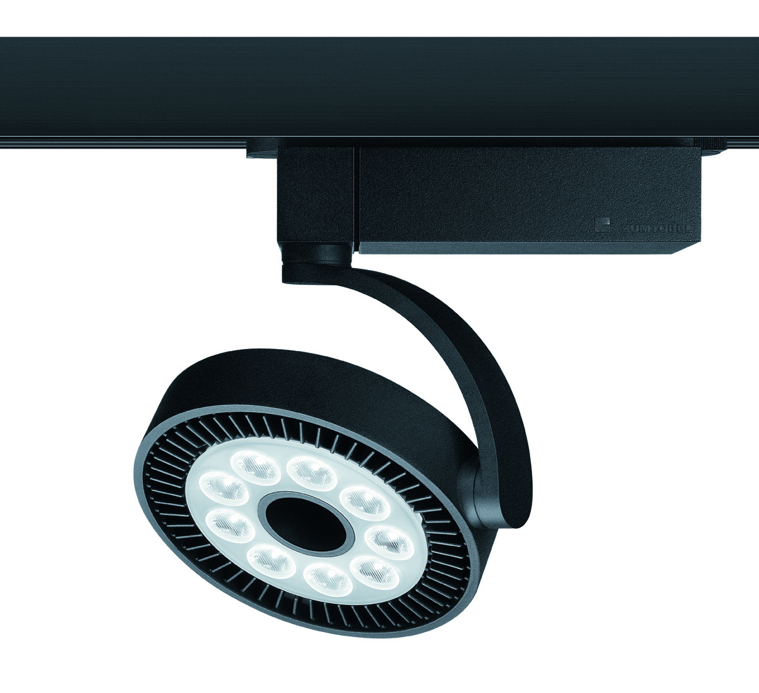

For more information, please contact:
Zumtobel Lighting GmbH
Nikolaus Johannson
Head of Brand Communication
Schweizer Strasse 30
A-6851 Dornbirn

Tel +43-5572-390-26427
Mobile +43-676-8920-3202
e-mail nikolaus.johannson@zumtobel.com

www.zumtobel.com

About Zumtobel
Zumtobel is a leading international supplier of integral lighting solutions that enable people to experience the interplay of light and architecture. As a leader in innovation, the luminaire manufacturer provides a comprehensive range of high-quality luminaires and lighting management systems for the most varied application areas of professional interior lighting – including offices and educational facilities, presentation and retail, hotels and wellness, health and care, art and culture as well as industry and engineering. Zumtobel is a brand of Zumtobel AG with its head office in Dornbirn, Vorarlberg (Austria).

Zumtobel. The Light.

