Press release

SFERA with SWARMCONTROL – the first LED free-standing luminaire featuring collective intelligence

Flexibility and adjustability are fundamental requirements with respect to optimal lighting quality at the workstation. With the SFERA LED free-standing luminaire and SWARMCONTROL technology, Zumtobel has created yet another milestone in innovative office lighting.

Dornbirn, November 2012 - Good lighting at the workstation is extremely important. After all, perfectly adjusted lighting provides for greater well-being, increased productivity and better communication at the workplace. With the SFERA free-standing LED luminaire, Zumtobel sets new standards in this area - especially with respect to adjustability and individual lighting quality. Yet SFERA offers more than just perfect lighting. Its energy efficiency is impressive, too. This is made possible through a combination of SENSCONTROL III - the latest version of adaptive lighting management by Zumtobel - and the innovative SWARMCONTROL technology that is used for the first time in this free-standing luminaire.

SWARMCONTROL
More flexibility and even more personalised light - those are the most outstanding features of the pioneering SWARMCONTROL technology by Zumtobel. This technology automatically configures the luminaires into a swarm or cloud. Without any additional software. Even if the arrangement of workstations in the office changes, SWARMCONTROL provides for quick and easy adjustment to altered room layouts.
Apart from this unique feature, two functions are characteristic of SWARMCONTROL: the corridor function and the presence-based function. The first primarily provides for safety and orientation: by means of built-in presence detecttor the luminaires are dimmed up one after the other, indicating the way to the workstation. The presence-based function, on the other hand, ensures ideal lighting conditions with a mean illuminance level of up to 500 lux at the workstation, while the quantity of light can be adjusted to individual needs at any time. Additionally, depending on the available amount of daylight and artificial light, a lighting cloud is formed following a radio signal to neighbouring luminaires, ensuring an optimal, pleasant room ambience, at the same time offering more visual comfort for the various tasks in hand.

What is more, SFERA guarantees glare-free work at the computer screen or tablet PC owing to its patented MPO+ optic. With light quantities of around 6300 lumens, a low installed load of 70 W and an LED service life of up to 50,000 hours, and with its high-grade material finish, the luminaire emphasises its high standard of efficiency and sustainability.

Facts & figures
Light distribution | Free-standing LED luminaire with separate, self-contained lighting chambers and asymmetrical direct/indirect light distribution  Indirect/direct light distribution: 54:46
Optic | Transparent plexiglass cover made of PMMA with integrated MPO+ light control technology (micro-prism optic in multi-layer design) as well as defined light emission and glare control according to EN12464
Built-in control system | SENSCONTROL III  SWARMCONTROL
Luminaire head dimensions | 650 x 420 x 34 mm
Stand dimensions | 45 x 70 mm
Height/luminaire | 1,950 mm
Service life | 50,000 hours at 70% luminous flux

Captions:

(Photo credits: Zumtobel)

Bild 1: In the SFERA free-standing LED luminaire by Zumtobel, innovative SWARMCONTROL technology is used for the first time.

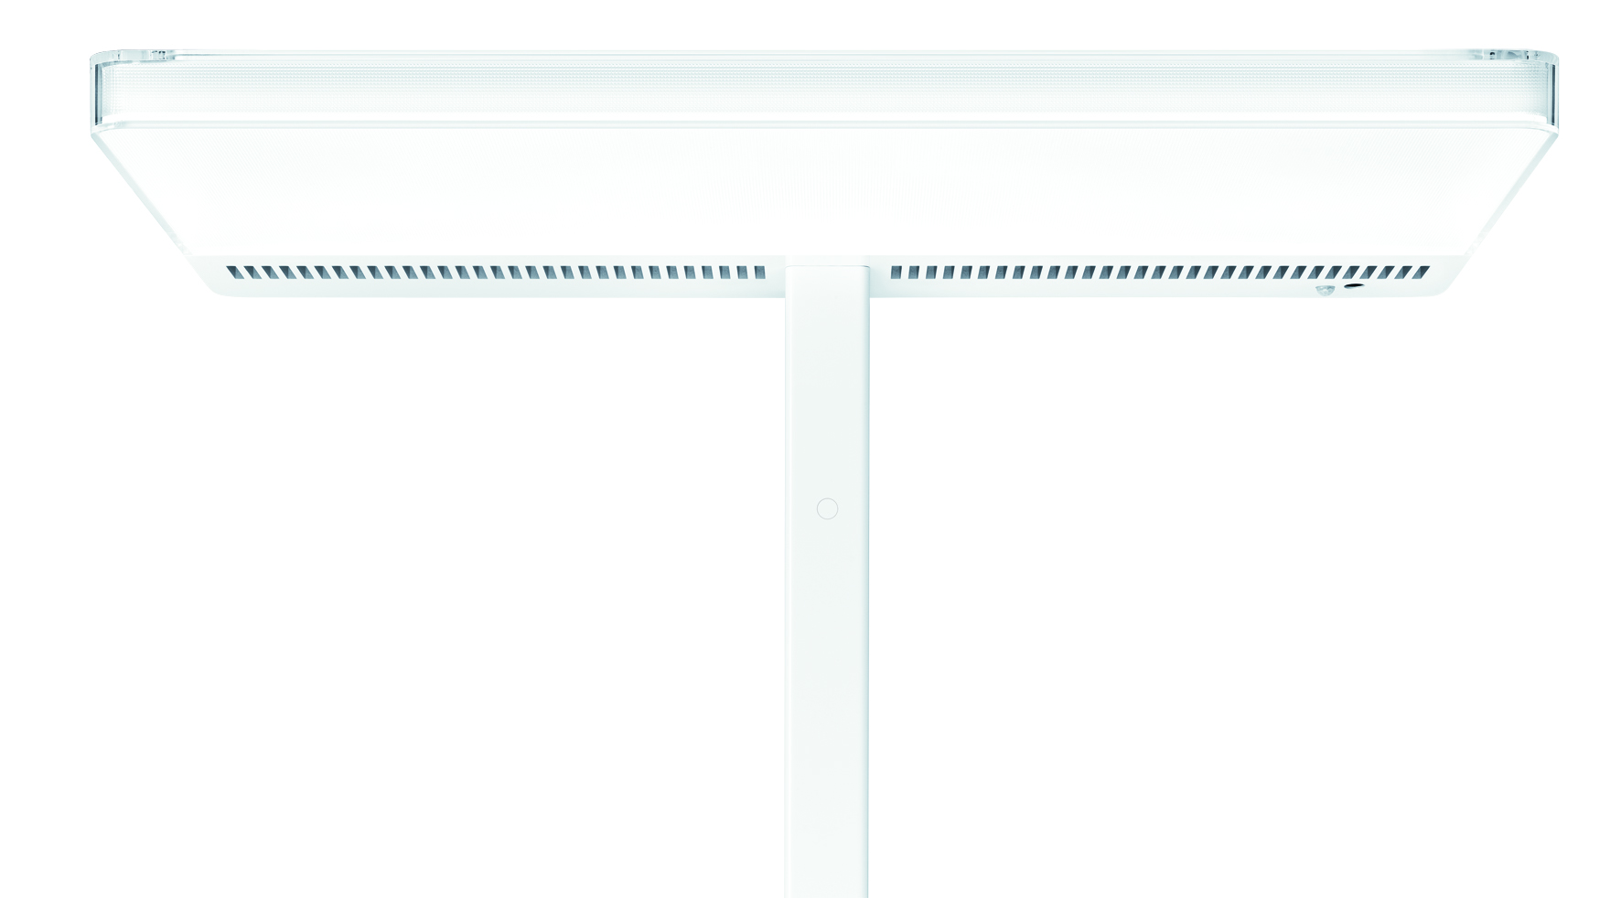

Bild 2: SWARMCONTROL has two essential functions – the corridor function and the presence-based function.
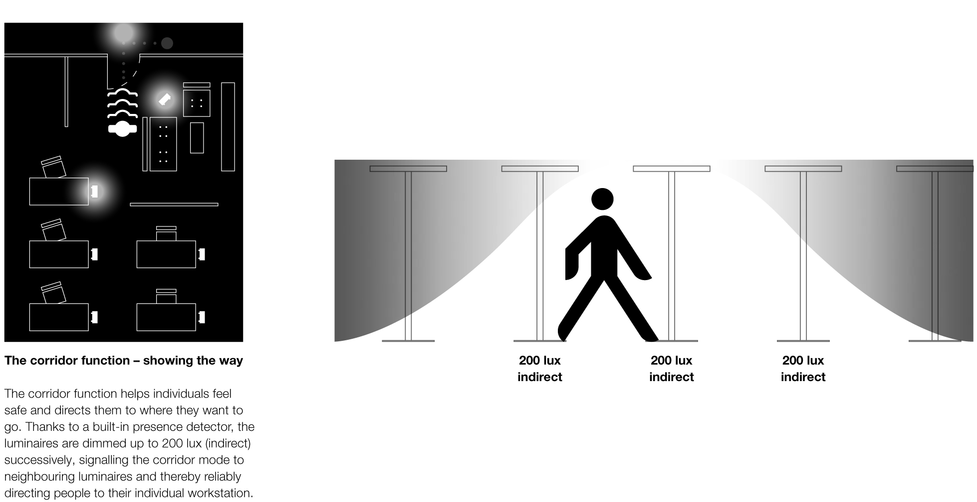

Caption 3: SWARMCONTROL is the new pioneering technology by Zumtobel for more flexibility and even more personalised lighting at the workplace.

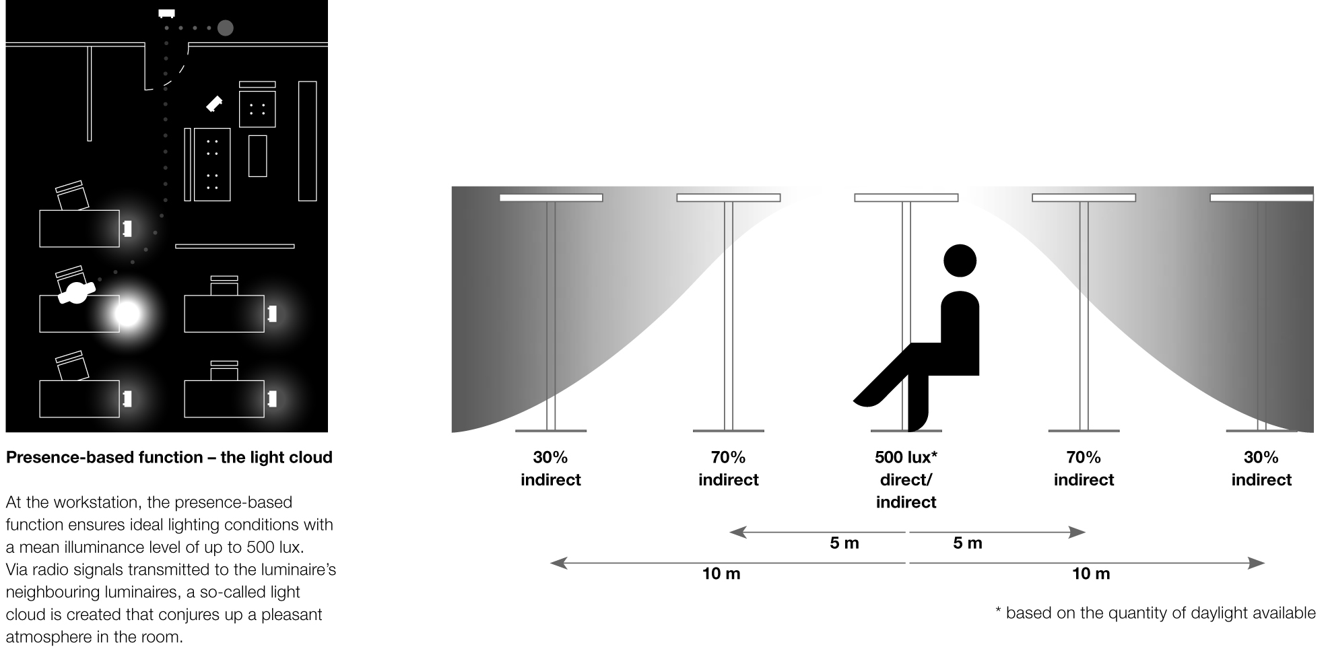

For more information, please contact:
Zumtobel Lighting GmbH
Nikolaus Johannson
Head of Brand Communication
Schweizer Strasse 30
A-6851 Dornbirn

Tel +43-5572-390-26427
Mobile +43-676-8920-3202
e-mail nikolaus.johannson@zumtobel.com

www.zumtobel.com

About Zumtobel
Zumtobel is a leading international supplier of integral lighting solutions that enable people to experience the interplay of light and architecture. As a leader in innovation, the luminaire manufacturer provides a comprehensive range of high-quality luminaires and lighting management systems for the most varied application areas of professional interior lighting – including offices and educational facilities, presentation and retail, hotels and wellness, health and care, art and culture as well as industry and engineering. Zumtobel is a brand of Zumtobel AG with its head office in Dornbirn, Vorarlberg (Austria).

Zumtobel. The Light.

