Press release

XPO for more efficient shelf lighting

With the smallest LED shelf lighting system currently available, Zumtobel once more emphasises its pioneering role in the efficient and authentic presentation of goods.

Dornbirn, November 2012 - The precise, authentic lighting of goods is part of the high art of illuminating retail spaces. The requirements are very high. LED luminaires are meant to put the products in the right light authentically and at the same time gently, while they ideally ought to disappear in the shelf and to offer various colour temperatures. XPO easily meets all these demands. The smallest, delicate LED shelf lighting system offered by Zumtobel is only 7 mm high and 11 mm wide. These dimensions are an important prerequisite for XPO luminaires to fit into the shelf unnoticed. The small size and Plug&Play technology of XPO offer a maximum of flexibility: it is available for shelves of 600, 1000 and 1200 mm, providing premium-quality, authentic illumination for any product through brilliant LED light combined with a specially developed shelf lighting optic. Individual lighting with different colour temperatures is especially important in shelf lighting. Therefore, XPO is available both in the Stable White version (colour temperatures 2700 K, 3000 K, 4000 K, and 5000 K) and in the Selectable White version, where the colour temperature can vary between 3000 K, 4000 K or 5000 K as required. Another strong point of the LED shelf lighting system is its quick, no-tool installation and its high efficiency of up to 72 lumens per watt. All this together with its long service life make XPO an efficient solution for the presentation of goods in supermarkets.

Facts & figures
Application | LED shelf lighting system for professional high-quality illumination of products on shelves
XPO Stable White | Versions with 2700 K, 3000 K, 4000 K and 5000 K ready-to-connect incl. white 2-pole 0.75 mm² cable (0.7m long) and plug-in connection
XPO Selectable White | Three different colour temperatures in one single luminaire  Switchable between 2700 K, 3000 K, 4000 K and 5000 K ready-to-connect incl. white 2-pole 0.75 mm² cable (0.7m long) and plug-in connection
Lengths | 545 mm, 923 mm and 1112 mm
Service life | 50,000h at 80% luminous flux

Captions:

(Photo credits: Zumtobel)

Bild 1: XPO is the smallest LED shelf lighting system by Zumtobel
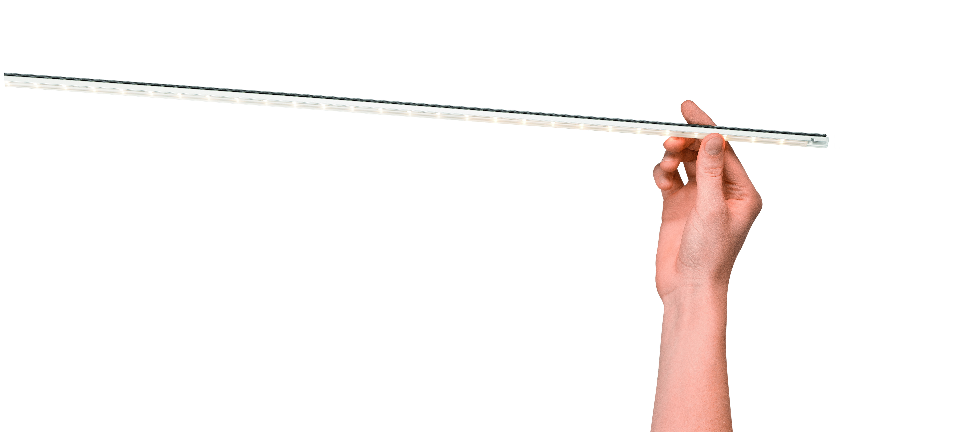

For more information, please contact:
Zumtobel Lighting GmbH
Nikolaus Johannson
Head of Brand Communication
Schweizer Strasse 30
A-6851 Dornbirn

Tel +43-5572-390-26427
Mobile +43-676-8920-3202
e-mail nikolaus.johannson@zumtobel.com

www.zumtobel.com

About Zumtobel
Zumtobel is a leading international supplier of integral lighting solutions that enable people to experience the interplay of light and architecture. As a leader in innovation, the luminaire manufacturer provides a comprehensive range of high-quality luminaires and lighting management systems for the most varied application areas of professional interior lighting – including offices and educational facilities, presentation and retail, hotels and wellness, health and care, art and culture as well as industry and engineering. Zumtobel is a brand of Zumtobel AG with its head office in Dornbirn, Vorarlberg (Austria).

Zumtobel. The Light.

