Press release
Dornbirn, April 2012

Lighting art at EYE, the new Amsterdam film museum
Unique ambience thanks to Starbrick, a Zumtobel Masterpiece

On 4 April, the EYE Film Institute Netherlands was opened – after having been relocated to a brand-new and above all larger building – in an inauguration ceremony attended by Queen Beatrix. The futuristic building has included 92 Starbricks, a work by artist Olafur Eliasson. Starbrick is part of Zumtobel's Masterpiece collection – works of lighting art developed by the luminaire manufacturer in collaboration with renowned architects, designers and artists.

Since 5 April, EYE, the only museum in the Netherlands that is exclusively dedicated to film and the moving image, has been located at its new home directly on the waterfront along the homonymous river IJ, right across Centraal Station. Owing to its exposed position, it is visible from afar. The gleaming white shell that covers its angular structure makes the building stand out from the cityscape like no other, also thanks to the dynamic design language used by the Vienna-based architectural studio of Delugan Meissl Associated Architects in charge of the building project. The architects started from the assumption that film is an illusion based on moving lights. This principle was translated into architecture, so that the building itself has become a kind of screen in its own right, showing a film the protagonists of which are the light, the city and the landscape of Amsterdam. Architect Roman Delugan sums up: “What we wanted to achieve was for the EYE museum to change its spatial appearance depending on the viewer's perspective and position. Like a mobile camera, ever new perspectives will open up to visitors as they pass through the building.”

Another special feature of the building is the arena covering 1,200 square metres that welcomes visitors who enter the futuristic building. Predominantly lined with wooden panelling and fitted with high-quality oak parquet flooring, the arena boasts an open, warm and pleasant atmosphere as well as a direct view across the river and the city. Visitors are welcomed by a pleasant ambience inviting them to stay for a while in the coffee bar, restaurant or bar to get in the mood for the show. Usually, it doesn't take long before the many seat cushions placed on the terraced stairs are occupied, where guests can enjoy a wonderful view of Amsterdam. “The spatial centerpiece of the building, the “arena”, invites visitors of the museum to stay for a while. The room's unique geometry promotes social interaction to a great extent”, Roman Delugan points out. The Starbrick installation contributes significantly to this effect. Starbrick is a Zumtobel Masterpiece, a collection of exclusive works of lighting art which the luminaire manufacturer has developed together with renowned partners. The highly versatile lighting module was made by artist Olafur Eliasson in collaboration with Zumtobel. “The Starbrick is a space-generating lighting module. Developing it together with Zumtobel we were able to create it for everyday use and living. I’m very excited to see it integrated into a public institution. The expandable system behind the geometric design enables the Starbricks to grow in all directions. For the new EYE museum foyer, the bricks form luminous cloud-like structures that conjure up the atmosphere of a cinema – stars for the stars”, explains artist Olafur Eliasson.

The basic structure of the Starbrick is a cube, on whose six surfaces additional cubes have been placed at an angle of 45°. Starbricks can be assembled to form groups of any size. Clusters consisting of one, two, four and even as much as seven modules were used at EYE. By joining these modules, floating sculptures were created for the arena that combine architecture, light and art in a unique way.

A total of 92 Starbricks – installed in 21 clusters of various configurations – seem to float in the arena, illuminating the room with exceptional light, especially at dusk and in the night. The Starbrick LEDs are arranged so as to emit white light. At the same time, they also create a luminous yellow and kaleidoscopic core in the shape of a cubeoctahedron. The Starbricks can be separately controlled via the central building management system. Thanks to the LEDs' dimming function, the museum is able to make use of a variety of light settings, either functional direct lighting, or indirect ambient lighting, or a combination of both.

Thus, movie buffs can now enjoy the largest film collection in the Netherlands in a building that has almost become a staging project in its own right. A total of 40,000 films are stored there – from the first silent movies dating back to the late 19th century to contemporary digital productions. In addition to its four cinema halls, the museum is provided with a spacious exhibition area and a variety of interactive sections for children and adults. Moreover, the museum organises open-air screenings, festivals and special children's showings.

Zumtobel. The Light.

Fact box:
Client: EYE Film Instituut Nederland, Amsterdam/NL
Architects: Delugan Meissl Associated Architects, Vienna/AT
Arena lighting design: Die Lichtplaner, Limburg/D in collaboration with Symetrys, Lustenau/AT
Arena lighting solution: Zumtobel – Starbrick Masterpiece

Brief profile
Zumtobel is a leading international supplier of integral lighting solutions that enable people to experience the interplay of light and architecture. As a leader in innovation, the luminaire manufacturer provides a comprehensive range of high-quality luminaires and lighting management systems for the most varied application areas of professional interior lighting – including offices and educational facilities, presentation and retail, hotels and wellness, health and care, art and culture as well as industry and engineering. Zumtobel is a brand of the Zumtobel group with its head office in Dornbirn, Vorarlberg (Austria).

More information/ media: More information/ sales, service:

Zumtobel Lighting GmbH Zumtobel Lighting GmbH
Nikolaus Johannson Martin Finkmann
Head of Brand Communication Masterpiece Management
Schweizer Strasse 30 Grevenmarschstr. 74 - 78
A-6850 Dornbirn D-32657 Lemgo

Tel. +43-5572-390-26427 Tel. +49 (5261) 212 4330
Fax.+43-5572-390-926427 Fax. +49 (5261) 212 81 4330
nikolaus.johannson@zumtobel.com martin.finkmann@zumtobel.com
www.zumtobel.com www.zumtobel.com/masterpieces

Captions:
Credits: Zumtobel

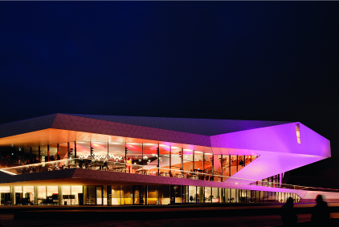
Figure 1: A real eye-catcher. The futuristic building of EYE, the new museum in Amsterdam is fascinating inside as well as outside.
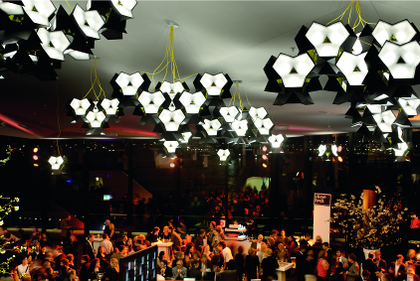
Figure 2: The Zumtobel Starbrick Masterpiece creates a unique atmosphere in the museum's arena. The Masterpiece was developed by Olafur Eliasson in collaboration with Zumtobel.

