Press release
Dornbirn, August 2012

Aberdeen leads way with complete LED shopping experience
Zumtobel's custom-made lighting solutions inspire proprietors and visitors alike

The lighting concept for “The Bon Accord and St Nicholas Centre” in Aberdeen gave Zumtobel yet another opportunity to demonstrate its prowess when it comes to integral lighting solutions. The company also delivered extremely high levels of innovation, lighting management and cost efficiency with a unique LED luminaire look that blends perfectly into the existing architecture.

The “Bon Accord and St Nicholas Shopping Centre” in the Scottish town of Aberdeen boasts 70,000 square metres of floor space and is a popular destination for numerous keen shoppers. Since its extensive refurbishment, this shopping paradise is also one of the first malls in the United Kingdom to feature an LED-only lighting solution so it is also bound to attract fans of integral lighting solutions. Colin Kennedy, Project Surveying Manager with the client Land Securities acting for owners Scottish Retail Property Limited Partnership explains: “We wanted to explore how the use of LED technology could improve the lighting levels, while also complementing the new finishes in the centre. We are extremely pleased with the result. We have lower maintenance costs, and we also have a balance between daylight and artificial light to give optimum energy consumption.”

Wallace Whittle who carried out an energy appraisal comparing the existing lighting to a lighting scheme utilising the Zumtobel LED luminaire proposal found that an annual saving of approximately 117’000 kW hrs, with a predicted annual carbon reduction of 49’000 kg CO2 could be realised. “The Zumtobel lighting solution proved to be the ideal fit for our vision for this project in order to deliver environmental improvements, enhance the shopping experience and reduce energy consumption.” explains Steve Bruce Senior Electrical Engineer at Wallace Whittle.

Tailor-made customer solutions
The clinching factor in Zumtobel winning the contract was the fact that the company was able to present a coordinated concept that embraced both architecture and lighting – and combined this with state-of-the-art standards such as using LED luminaires and lighting management systems. Intensive discussions between architects, electrical designers and Zumtobel ensured optimum integration into the existing design and made sure that the LED technology inside the luminaires delivers the best possible lighting comfort. The development team met on-site in the United Kingdom several times in order to take a close look at the luminaires.

Graeme Nicholls from Gareth Hoskins Architects' explains: “We were pleased to work in close collaboration with Zumtobel to design a series of bespoke circular LED lights. Through a series of workshops, the design intent was discussed and a number of prototype fittings were developed in order to ensure that the final product exactly met the technical and aesthetic aspirations.” Thanks to square LED luminaires from the Careena product range, which were precisely adapted to fit the 481 mm round cut-outs in the shopping centre's ceiling, Zumtobel managed to pull off a unique luminaire look. These advanced LED luminaires also save considerable energy thanks to their low installed load and Zumtobel's specially developed MPO+ micro-pyramidal optic. The plain, uncluttered stylistic idiom of the Careena custom solution creates a timeless vista.

Lighting solution specialist Zumtobel developed another custom solution for the Resclite LED spots. Usually, these LED spots are used to guide visitors safely away from danger in the event of an emergency. In Aberdeen, however, these small LED power packages are also used to provide highlighting in everyday use. Specially tailored to fit a ceiling panel size of 31 mm, these round spots brighten up the shopping centre's roof with brilliant lighting accents, thereby creating the impression of a starry sky. As well as these two custom solutions, various standard Zumtobel LED products are also used in public areas. Light lines and downlights, for instance, provide varied ambient lighting. They make it easier for people to find their way around and facilitate shopping trips in a cosy, bright ambience.

Quality and service in a single package
Zumtobel was again able to successfully put its expertise in deploying high lighting quality and exploiting its effect on people to the test in Aberdeen. Implementing an efficient concept for saving energy ultimately makes this lighting solution a unique combination. The client opted to use Zumtobel's Luxmate Professional lighting management system in order to make the best possible use of daylight and artificial lighting. This intelligent system makes it possible to dim and control the LED luminaires efficiently and even program lighting scenes that mimic natural changes over the course of the day. This way, the right lighting ensemble is always available at the press of a button during opening hours, when cleaning takes place, and also at night.

Zumtobel. The Light
Project information:
Client: Scottish Retail Property Limited Partnership, a joint venture between Land Securities and British Land
Architets: Gareth Hoskins Architects, Glasgow/UK
Electricals consultants and installations: Wallace Whittle, Aberdeen/UK

Lighting solution: Careena LED luminaires – custom solution, Panos Infinity LED downlights, Slotlight LED RGB light lines, Decoline light lines, Micros downlights, Resclite emergency lighting – custom solution, Hedera façade luminaires
Lighting control: Luxmate Professional
Captions
(Copyright: www.nealsmith.com)

Image 1:
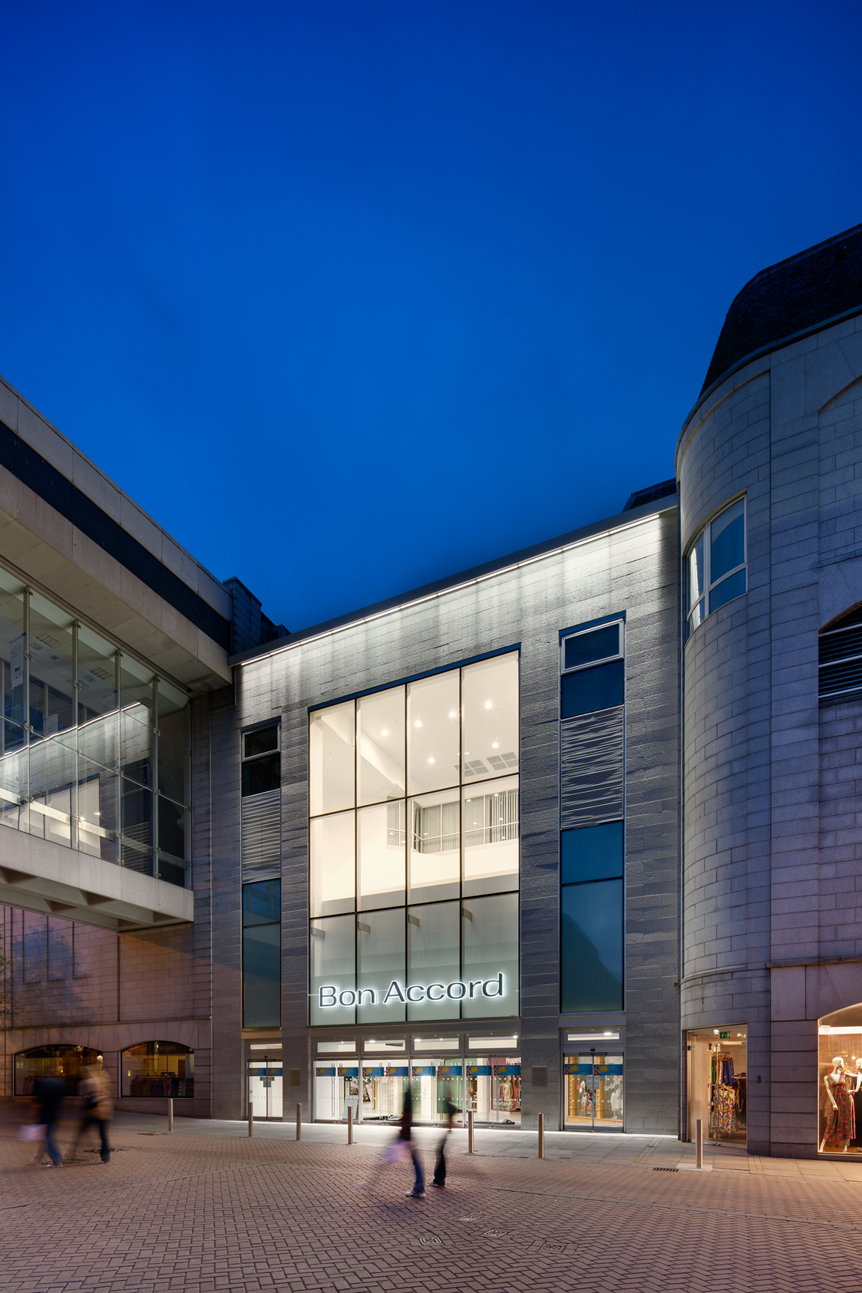
A coordinated concept that embraced both architecture and lighting and combined this with state-of-the-art standards such as using LED luminaires and lighting management systems is used.

Image 2:
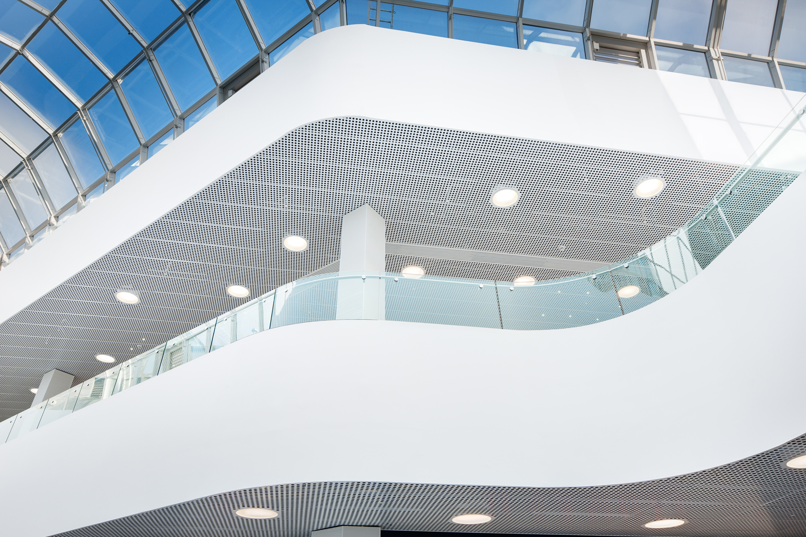
Thanks to square LED luminaires from the Careena product range, which were precisely adapted to fit the 481 mm round cut-outs in the shopping centre's ceiling, Zumtobel managed to pull off a unique luminaire look.

Image 3:
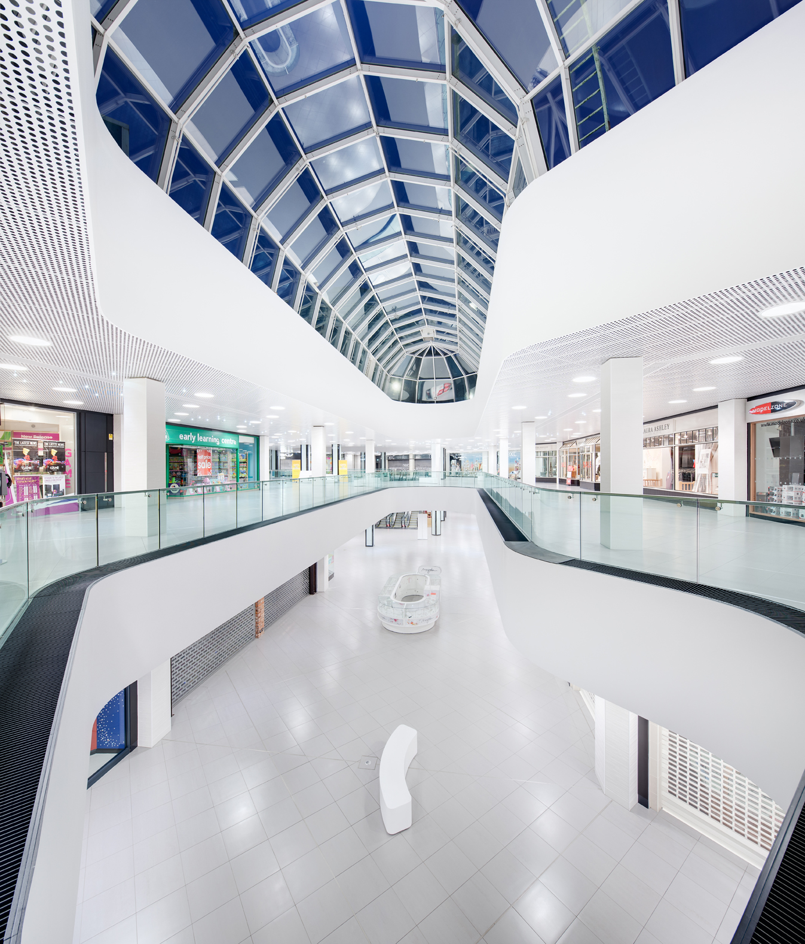
The intelligent Luxmate Professional system makes it possible to dim and control the LED luminaires efficiently and even program lighting scenes that mimic natural changes over the course of the day.

Brief profile
Zumtobel is a leading international supplier of integral lighting solutions that enable people to experience the interplay of light and architecture. As a leader in innovation, the luminaire manufacturer provides a comprehensive range of high-quality luminaires and lighting management systems for the most varied application areas of professional interior lighting – including offices and educational facilities, presentation and retail, hotels and wellness, health and care, art and culture as well as industry and engineering. Zumtobel is a brand of the Zumtobel group with its head office in Dornbirn, Vorarlberg (Austria).

For more information, please contact:

Zumtobel Lighting GmbH Zumtobel Lighting GmbH
NikolausJohannson Britta Maier
Head of Brand Communication PR Manager
Schweizer Strasse 30 Schweizer Strasse 30
A-6850 Dornbirn A-6850 Dornbirn
Tel. +43-5572-390-26427 Tel. +43-5572-390-26527
Fax +43-5572-390-926427 Fax +43-5572-390-926527
nikolaus.johannson@zumtobel.com britta.maier@zumtobel.com
www.zumtobel.com www.zumtobel.com

