Press release

Contemporary lighting art by Zumtobel at the Kunstkammer Wien

One of Austria's most important cultural projects is the reopening of the Kunstkammer (literally, chambers of art and natural wonders) in Vienna. Zumtobel was able to make an essential contribution ensuring the state-of-the-art presentation of this unique collection by providing a very special lighting solution.

Vienna/Dornbirn, March 2013 – After having been closed for more than 10 years, the Kunstkammer was presented to the public again on 1 March, with the explicit goal of making the history of the Habsburg collection and its most important figureheads known to an interested contemporary audience. The highest conservation requirements, content-related didactic criteria, but also emotional factors played an equally essential role for the new presentation of the Kunstkammer. Yet, the 2,200 exhibits included in the collection could not be more different in nature: among the highlights are outstanding works of the goldsmith’s art, such as the famous Saliera by Benvenuto Cellini, first-rate specimens of sculpture, such as the Krumau Madonna, masterly bronze statuettes, filigree ivory objects, but also precious clocks, games and scientific instruments.
Zumtobel has developed a customised LED lighting solution in order to obtain a highly differentiated, gentle and effective illumination of the various objects on display. “The point was literally to present the objects in the best possible light. All exhibits are originals, and each of them has its very special aura that we want visitors to be able to feel and experience,” says Sabine Haag, General Director of the Kunsthistorisches Museum. At the heart of the lighting solution is the Starbrick, a Zumtobel Masterpiece developed in collaboration with Danish-Icelandic artist Olafur Eliasson. Boasting unpretentious elegance and multi-functionality, the Starbrick is the only representative of contemporary art and cutting-edge technology in these rooms of the museum that were opened for the first time in 1891. The installation includes a total of 51 Starbrick assemblies consisting of four modules each, especially designed for illuminating the unique and sensitive works of art. Additional direct light is ensured by integrated Supersystem spotlights and indirect light is provided by a Panos Infinity module, while one of the Starbrick's surfaces that is directed downwards doubles as emergency lighting. “Due to the height of the ceiling, we had to increase the levels of light intensity, but the original shape of the Starbrick remained unchanged. Taking the historical rooms into particular consideration, a highly specific Starbrick assembly was created, so that the modules work like a picture, like stars in the sky,” explains Olafur Eliasson.
In addition to LED Supersystem spotlights mounted on the walls, single Supersystem spotlights were also installed in the showcases. Especially in the showcases, each of them a highly sensitive closed system, the benefits of LED technology can be fully exploited. Thus, light-emitting diodes not only boast a long service life and high energy efficiency, combined with reduced maintenance cost, but also ensure an effective and at the same time gentle presentation of the exhibits. Moreover, the light colours can be individually matched to the colours and materials of the exhibits, so that they can unfurl their full charm and allow visitors to experience them authentically.

“Illuminating this significant and unique collection in a contemporary way has been a special project for us. In collaboration with architects, designers and Olafur Eliasson we managed to develop a lighting solution that is in line with the new concept of the Kunstkammer, meeting the most demanding conservation requirements and providing the best light for an unrestricted enjoyment of art,” says Reinhardt Wurzer, Director International Projects, Zumtobel Lighting.

About the Starbrick
Four individual works of lighting art, the Masterpieces, have been created in close cooperation between Zumtobel and international architects, designers and artists. The Starbrick is a versatile lighting module. Its basic structure is a cube, on whose six surfaces additional cubes have been placed at an angle of 45°. These additional cubes serve as connectors to combine several Starbrick modules.
For more information about the Starbrick see www.starbrick.info.

About Olafur Eliasson:
Olafur Eliasson was born in Copenhagen in 1967, where he studied at the Royal Danish Academy of Fine Arts. In 1995, he established the Berlin-based Studio Olafur Eliasson, a laboratory for spatial research, where jointly with a team of architects, art historians as well as materials and lighting experts he creates works of art such as extensive installations, photo series and sculptures.

Captions:

(Photo credits: Zumtobel)
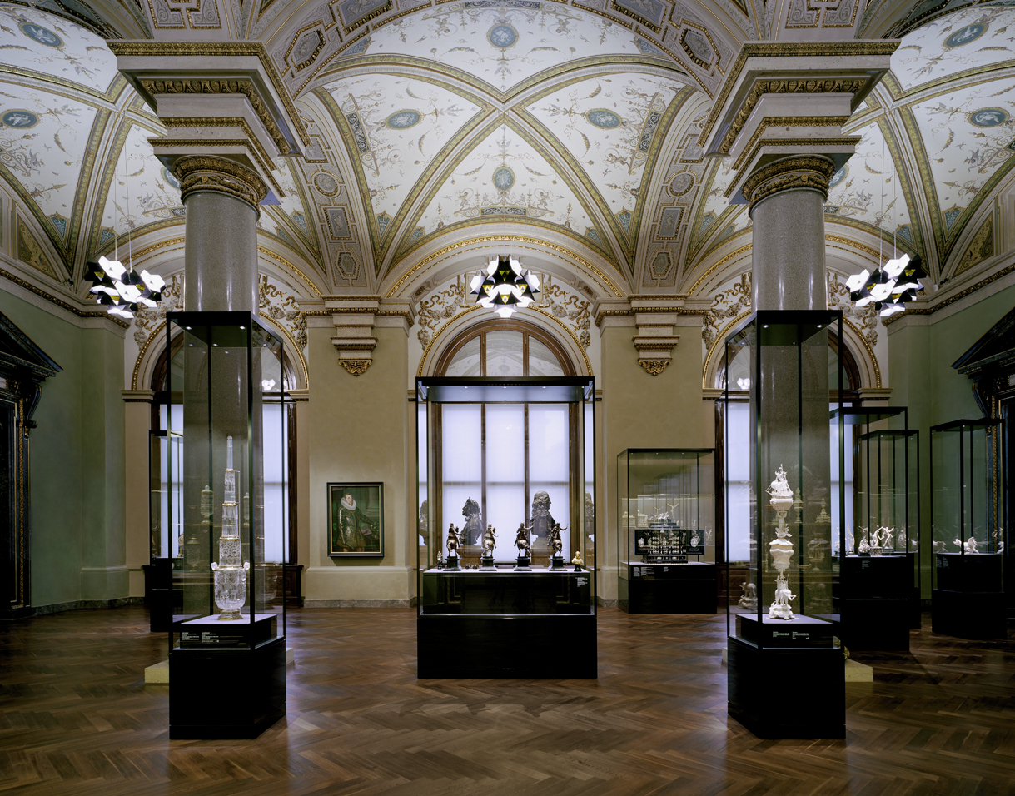
Picture 1: Contemporary lighting art by Zumtobel ensures the state-of-the-art presentation of exhibits at the Kunstkammer Wien.

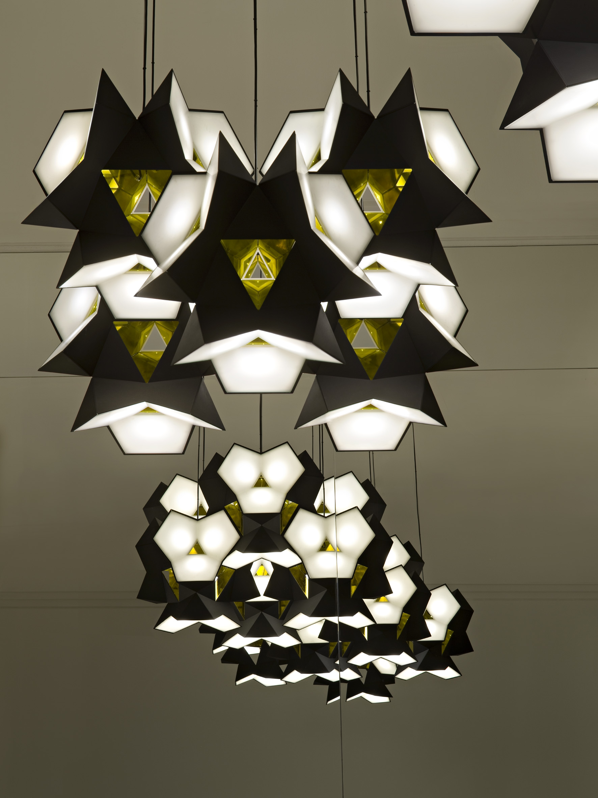
Picture 2: In collaboration with artist Olafur Eliasson, Zumtobel has developed the Starbrick Masterpiece.

Fact box:
Client | Kunsthistorisches Museum (Museum of Art History), Vienna
Architecture | Studio HG Merz Architekten, Stuttgart
Lighting design | Die Lichtplaner, Torsten Braun, Limburg
Lighting concept | Symetrys, Herbert Resch, Lustenau
Electrical consultants | IB Süd Wien
Lighting solution | Zumtobel Starbrick Masterpiece (special design), custom version of single Supersystem spotlights installed in showcases, wall-mounted Supersystem spotlights (cornices and capitals), Onlite LPS emergency lighting

For more information, please contact:
Zumtobel Lighting GmbH
Nikolaus Johannson
Head of Brand Communication
Schweizer Strasse 30
A-6851 Dornbirn

Tel. +43-5572-390-26427
Mobile +43-676-8920-3202
E-mail nikolaus.johannson@zumtobel.com

www.zumtobel.com

About Zumtobel
Zumtobel is a leading international supplier of integral lighting solutions that enable people to experience the interplay of light and architecture. As a leader in innovation, the luminaire manufacturer provides a comprehensive range of high-quality luminaires and lighting management systems for the most varied application areas of professional interior lighting – including offices and educational facilities, presentation and retail, hotels and wellness, health and care, art and culture as well as industry and engineering. Zumtobel is a brand of Zumtobel AG with its head office in Dornbirn, Vorarlberg (Austria).

Zumtobel. The Light.

