Press release
Dornbirn, March 2012

A new quality of light for people and the environment
Zumtobel highlights at light+building

Zumtobel is showing innovative lighting solutions for people and the environment at this year's light+building that will be held from 15 to 20 April in Frankfurt (hall 2.0, stand B30/B31). Zumtobel's motto is “Your Light in a World of Change”, and the company is focusing on global changes and their impact on the space in which we live and work. For companies and organisations all over the world, the quality of space and light is becoming a success factor in coping with vital tasks. In a world of change, Zumtobel has identified the need for a new quality of light: lighting solutions that cater intelligently and individually for users' needs, create added value for customers, but are also in harmony with the environment.

Highlights by Zumtobel
Modern requirements placed on offices, shops, health-care facilities and museums demand lighting solutions that are adaptable. Solutions that are capable of being adjusted to suit a wide variety of architectural tasks and fostering a sense of well-being. At light+building, Zumtobel will therefore present solutions and ideas which above all focus on customer benefits. Visitors will be impressed by the 780 m² Zumtobel stand on account of the way in which the subject of light is presented in terms of architecture, and because of its design quality. Light becomes the principal performer leading visitors through a variety of working and living spaces. Zumtobel will present the most important trends and requirements for each application area. Visitors can experience how adaptive lighting solutions, combined with modern control systems, are able to increase well-being and performance, reduce costs, and create corporate identities as well as added value.

In each application area, Zumtobel will present product innovations and extended product ranges which are able to create unique customer benefits thanks to their quality and functionality:

- The Zumtobel Group is the first organisation in the lighting industry to have products of its Zumtobel, Thorn and Tridonic brands certified with Environmental Product Declarations (EPDs). These environmental data sheets based on international standards document the environmental impact of a product in terms of CO² emission, recycling percentage or material composition across the product's entire production and service life cycle. By introducing these new EPDs Zumtobel is underscoring its intention to manufacture luminaires with maximum utility value in a sustainable manner.
- The Arcos LED projection spotlight, which is able to provide unique accent lighting, points the way when it comes to demonstrating the extended museum lighting options that are now available. The Microtools LED lighting system which recently won an iF Gold Award will also inspire trade fair visitors with its minimalist design and brilliant lighting quality for any type of showcase and shelf lighting.
- In the field of emergency lighting, too, Zumtobel LED luminaires cannot fail to impress. Zumtobel is enabling customers to reap the benefit of modern, functional design teamed with the very best lighting quality and energy efficiency with its three new ONLITE escape sign luminaires.
- The Litenet Tunable White control unit is another highlight of the trade fair. So far, only complex, daylight-based lighting solutions have been possible, but now lighting management has also been upgraded to include lighting controls with a variable colour temperature capability.

Stefan von Terzi, Zumtobel Marketing Director, explains: “In a world characterised by change, light must be adaptive. For us, this means that we provide our customers with a new quality of light: light that responds automatically and intelligently and adapts to changes in users' environments and needs. Moreover, by being the first to publish our Environmental Product Declarations we are expressing the responsibility we feel towards people and the environment. The combination of both emphasises our ambition of providing our customers with optimum lighting quality and maximum energy efficiency, as well as providing professional advice and supplying trend-setting lighting solutions for customers all over the world.”

Zumtobel. The Light.

Brief profile
Zumtobel is a leading international supplier of integral lighting solutions that enable people to experience the interplay of light and architecture. As a leader in innovation, the luminaire manufacturer provides a comprehensive range of high-quality luminaires and lighting management systems for the most varied application areas of professional interior lighting – including offices and educational facilities, presentation and retail, hotels and wellness, health and care, art and culture as well as industry and engineering. Zumtobel is a brand of the Zumtobel group with its head office in Dornbirn, Vorarlberg (Austria).

For more information, please contact:

Zumtobel Lighting GmbH
Nadja Frank
PR Manager
Höchsterstrasse 8
A-6851 Dornbirn

Tel. +43-5572-390-1303
Fax +43-5572-390-91303
nadja.frank@zumtobel.com
www.zumtobel.com

Captions:
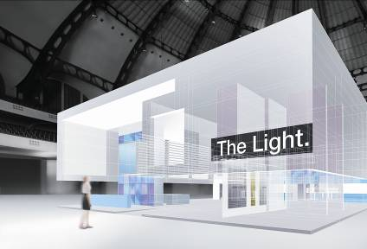

Caption 1: “Your Light in a World of Change”: the Zumtobel stand at light+building will focus on trend-setting lighting solutions for a world determined by change

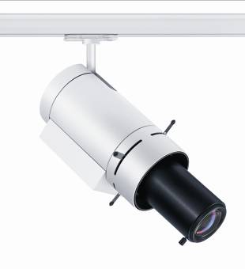

Caption 2: The Arcos LED projection spotlight ensures focused, sharp-edged accent lighting in museums



Caption 3: Stefan von Terzi, Zumtobel Marketing Director

Caption 4: At the fair Zumtobel will present a new range of Onlite emergency lighting luminaires: Onlite Crossign, Onlite Comsign, Onlite Puresign (Design: EOOS)
