Press Release

Half luminaire, half artwork
Regional premiere of Zumtobel Masterpieces at Design Days Dubai 2015
Dubai, February 2015 – The Zumtobel masterpieces are visions of international artists and architects like Olafur Eliasson, Zaha Hadid, Hani Rashid and Daniel Libeskind that have become reality. With the support of Zumtobel their creative ideas transformed into half luminaire, half artwork. At the Design Days Dubai 2015, Zumtobel will present 3 of these sensational Masterpieces for the first time in the Middle East in cooperation with the renowned Italian designers Sawaya & Moroni.
The Design Days Dubai offers the unique opportunity to discover how Starbrick by Olafur Eliasson experiments with light and space. The versatile modules can be used in a number of ways: as a pendant, floor or table luminaire. Modules can be linked up to build free-standing or suspended sculptures, ceilings or walls. Modern LED technology provides for flexible lighting options.
Be mesmerized by VorteXX by Zaha Hadid and witness the perfect symbiosis of organic lines in combination with dynamic modulation of light colours. This impressive design is based on the vision of an infinite ribbon of light. Its charismatically curved outlines are reminiscent of a double helix and seem like a continuously flowing form – weightless, impulsive and radiant. VorteXX creates harmonious lighting scenes wherever it is installed and has a sustainable impact on people's sense of well-being.
Let LQ Chandelier captivate your senses. Designed by the renowned architect and artist Hani Rashid, LQ shows the contemporary interpretation of the historic candelabrum. The lighting effect of the chandelier is achieved by reflection, yet the source of enlightenment, the LED module, is imperceptible to the beholder.
The interplay between art and light comes alive through the Zumtobel Masterpieces. Together with Sawaya & Moroni, Zumtobel invites you to change your perspective and experience the mutual inspiration of light and art paving the way to innovation.
This reflects as well on Zumtobel’s lighting solutions for professional indoor and outdoor building applications. Zumtobel unfolds the full potential of lighting by combining comprehensive lighting knowledge, the impact of light on people and the environment with aesthetic design and latest technology.

About the Design Days:
Design Days Dubai is the leading fair in the Middle East and South Asia dedicated to collectible and limited edition furniture and design objects. The fair presents design from leading international designers and galleries alongside up and coming design from across the world. The fair also presents a strong non-commercial programme consisting of education, workshops, installations and live performances. The fair will take place from 16th – 20th March 2015.
(Photo Credits: Zumtobel)

Picture 1: Starbrick Olafur Eliasson

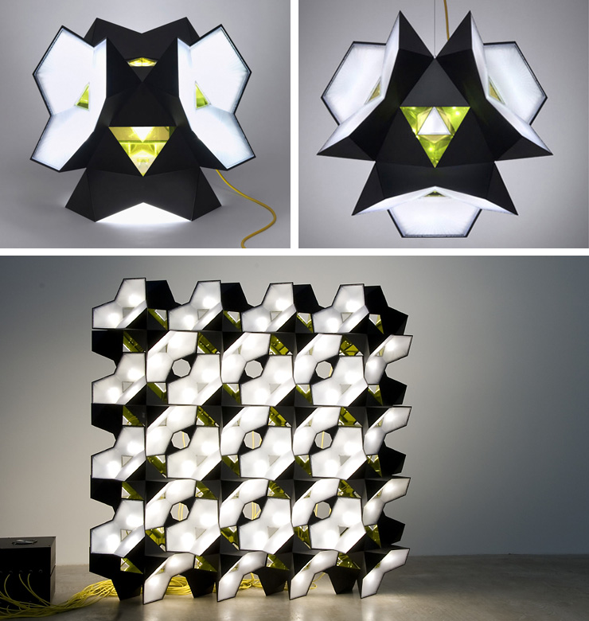

Picture 2: VorteXX Zaha Hadid

Picture 3: LQ-P-Chandelier Hani Rashid

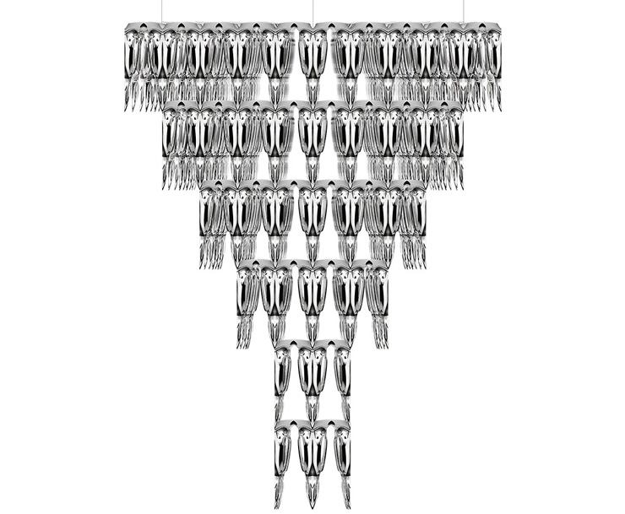

Press contact:
Zumtobel Lighting GmbH
Donna Dederding
Marketing Specialist
4B Street, Al Quoz Industrial Area
Dubai, United Arab Emirates
T +971 4 3404646 Ext.: 107
M +971 50 554 6959
donna.dederding@zumtobelgroup.com
www.zumtobel.ae

About Zumtobel:
Zumtobel is a leading international supplier of integral lighting solutions that enable people to experience the interplay of light and architecture.

As a leader in innovation, the luminaire manufacturer provides a comprehensive range of high-quality luminaires and lighting management systems for the most varied application areas of professional interior lighting – including offices and educational facilities, presentation and retail, hotels and wellness, health and care, art and culture as well as industry and engineering. Zumtobel is a brand of Zumtobel AG with its head office in Dornbirn, Vorarlberg (Austria).

The Light Centre in Dubai represents Zumtobel in the Middle East, India, Africa, Central Asia and Turkey. The Light Centre enables ligthing professionals to experience lighting solutions for various applications and discover the impact lighting can have. Please visit us on dubai.zumtobel.ae
Zumtobel. The Light.

