Press release
Dornbirn, February 2012

2012 iF product design awards for three Zumtobel products
Microtools LED lighting system wins iF gold award

Once again, Zumtobel was able to demonstrate its design expertise at the iF International Forum Design. On 10 February 2012, as many as three products by Zumtobel will receive iF product design awards. The Microtools LED lighting system in particular could not fail to impress the jury with its minimalist design language and was given one of the 100 much-sought-after iF gold awards. Featuring high-quality design and excellent lighting quality, the Microtools LED lighting heads, the smallest currently available on the market, set new standards for shop lighting and comply with the most advanced requirements. Moreover, the Iyon LED spotlight system and the Ondaria circular luminaire won awards for their outstanding product design and highly efficient lighting technology.

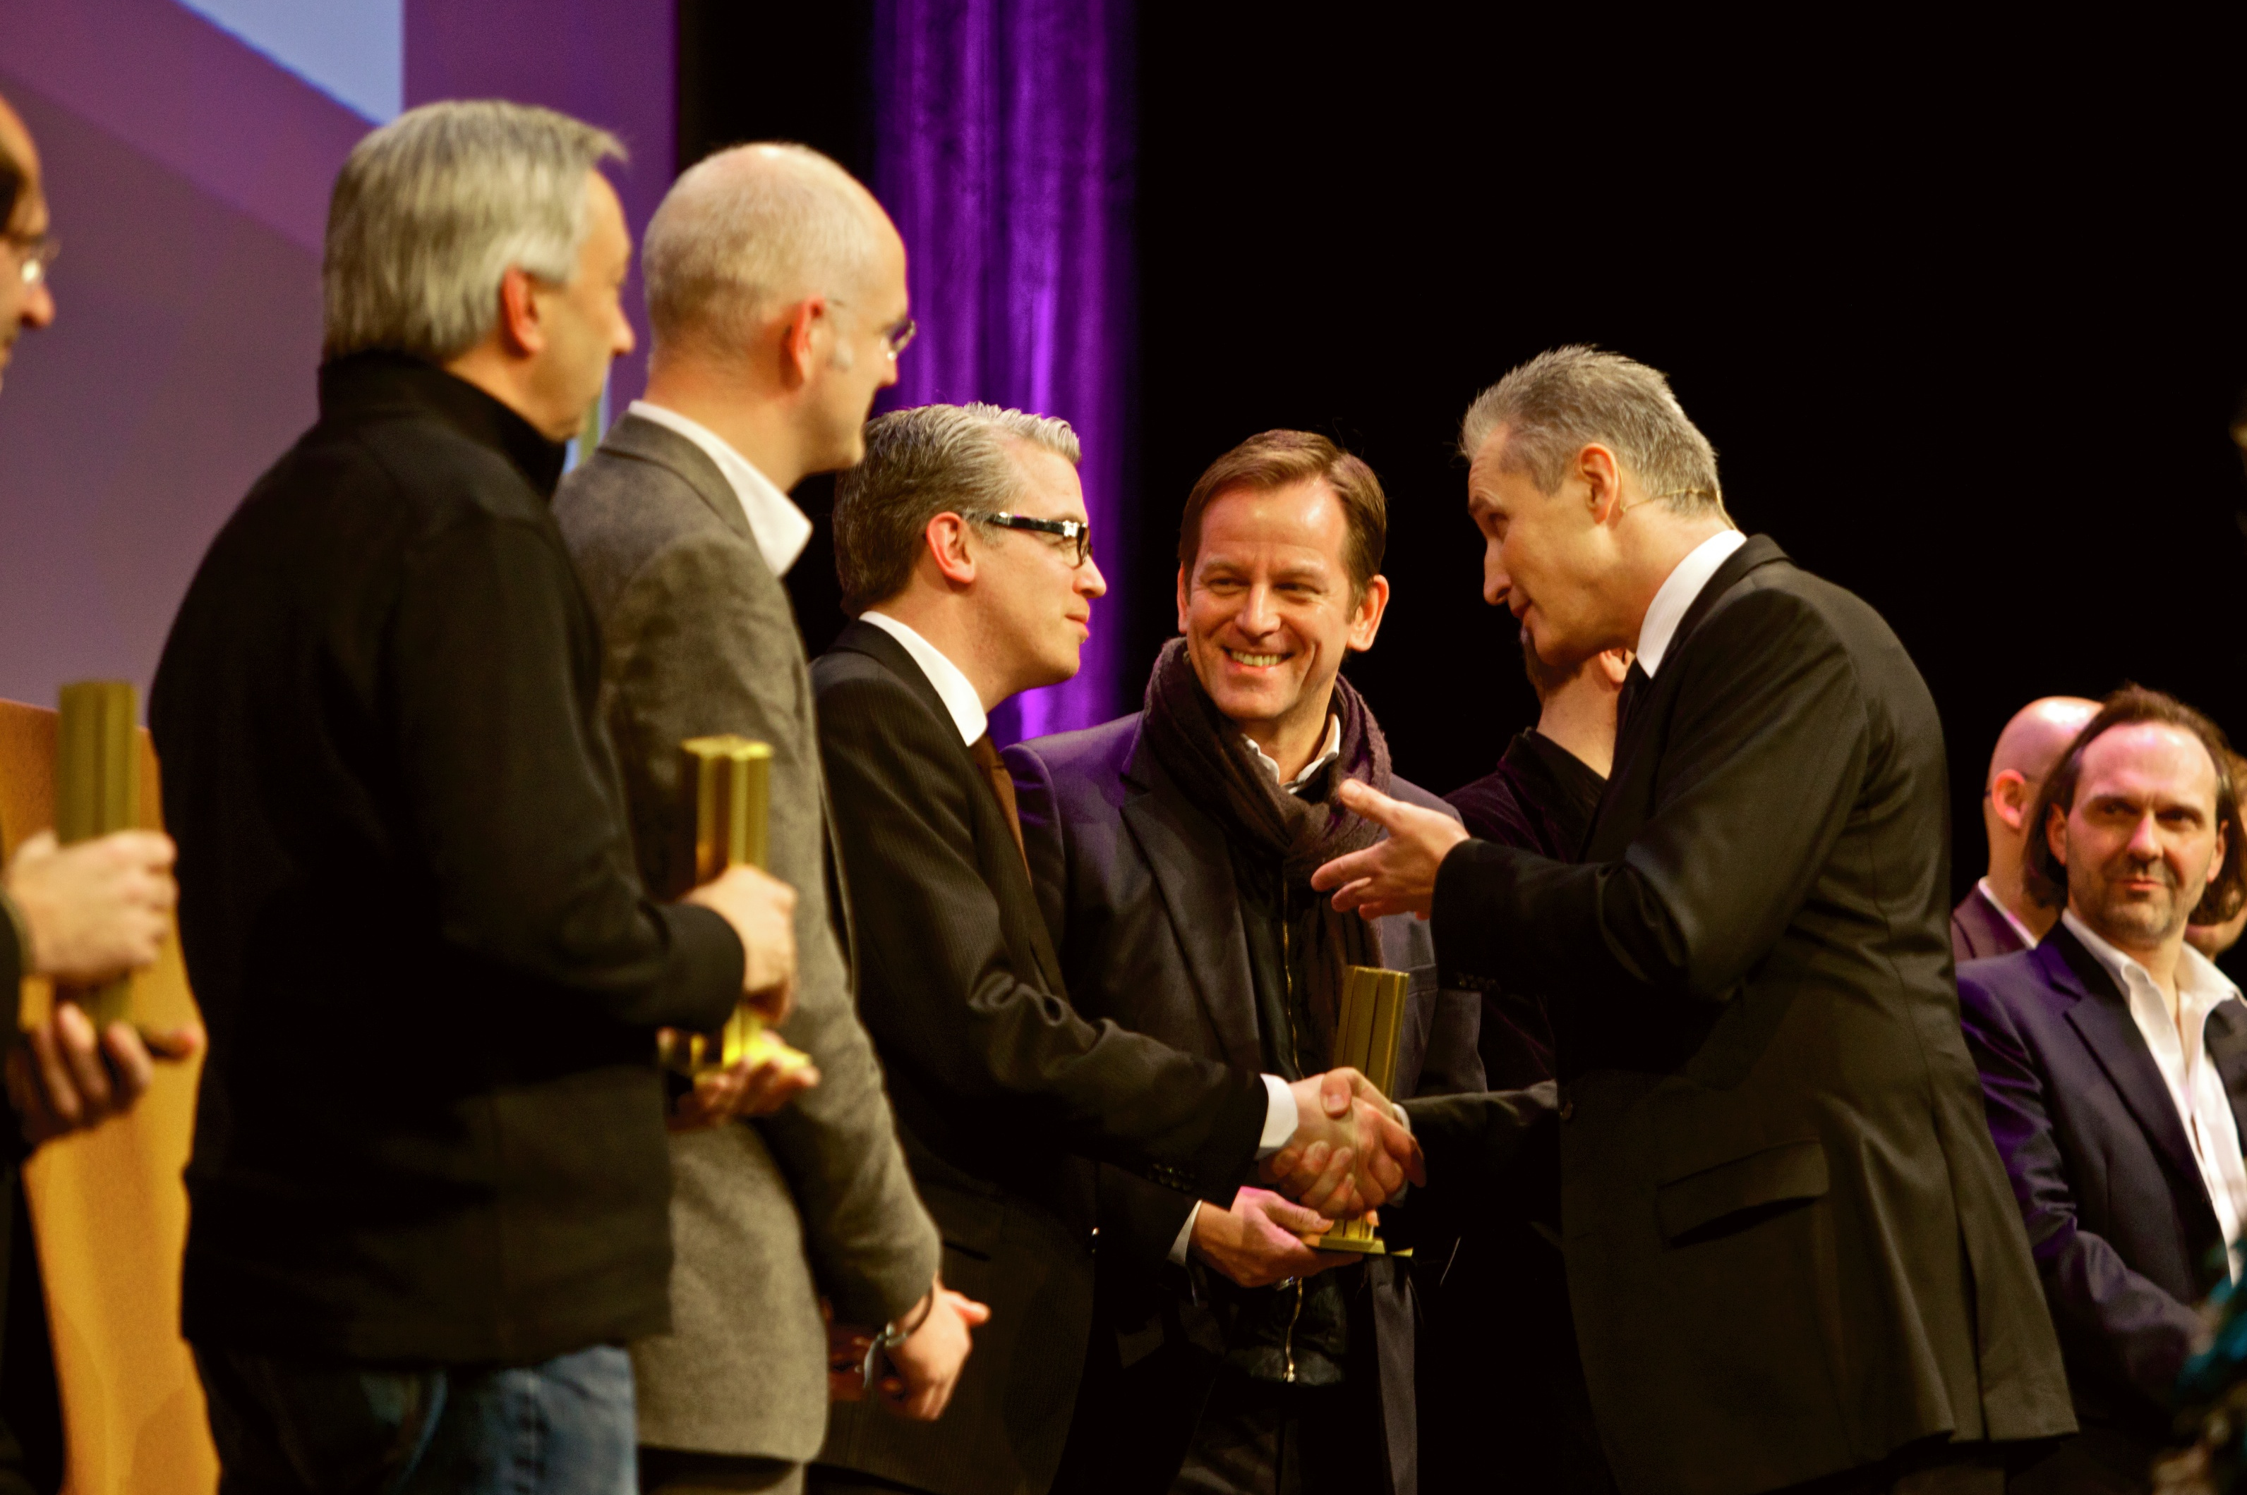
Zumtobel Marketing Director Stefan von Terzi explains: “Each Zumtobel product originates from our vision – to create the best possible light for people and the environment. In the process, successful product design evolves from our knowledge about applications and user requirements. This means that our products, which are frequently developed in collaboration with external design partners, are not only an expression of design, but also a manifestation of our brand and the values it stands for. The power of this notion is shown by the fact that the iF product design award has granted several awards to Zumtobel as a globally leading supplier of professional lighting solutions. We share our designers' pleasure, and would like to thank the iF jury very much.”
The iF awards are among the most important design labels in the world. Winners are chosen by independent juries comprising internationally renowned designers, businessmen and professors according to specific pre-defined criteria. Each year, the best designs of innovative companies are given awards in various categories. The iF award is considered an indicator of future-oriented design trends and product innovations. Entries for the famous design award included a total of 4,322 products submitted by more than 1,600 international competitors. 1,218 of these products have won an award. In addition to the iF design exhibition, which will be held from 6 to 10 March 2012 in Hanover, all products will for the first time also be on display for several months in a permanent exhibition to be held at the Hamburg HafenCity in the second half of 2012.

Microtools – LED lighting system
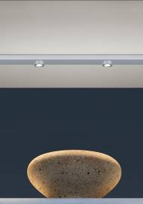
The Microtools LED lighting system cannot fail to impress on account of its minimalist design language, high-quality manufacture from silver anodised aluminium and excellent lighting quality.It was especially developed for recess into or surface-mounting on wooden shelves, glass and metal boards. Modules for general and accent lighting that are easy to combine ensure sophisticated shelf lighting. The gimbal-mounted lighting heads are among the smallest currently available on the market. The front ring of the 1.1 W LED spots protrudes only 4 mm from the modules. Thanks to excellent colour rendering (Ra > 90), Microtools is able to emphasise even the smallest product details as elegant highlights while remaining perfectly unobtrusive itself.

Iyon – LED spotlight range
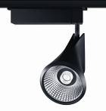
The Iyon spotlight range incorporates state-of-the-art LED technology in a sophisticated design by Delugan Meissl Associated Architects. Its flowing lines give the Iyon spotlight an elegant look, combined with high functionality. The sophisticated spotlight design incorporates a unique lens/reflector system that provides brilliant accents with a variety of beam patterns. Luminaire luminous flux levels of 1000-1200 lm, 1700-2100 lm and 2300-2800 lm in Stable White are an efficient alternative to HIT luminaires of up to 50 W. Excellent colour quality (Ra > 90) ensures authentic and natural lighting scenarios of the highest standards. The die-cast aluminium housing allows for purely passive cooling of the LED modules.

Ondaria – opal circular luminaire
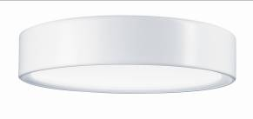
The design (by Stefan Ambrozus) and lighting effects of the Ondaria circular luminaire speak the same language: the luminaire's slightly concave surface matches its soft design and enhances its three-dimensional appearance. Uniformly lit, Ondaria makes sure that the outlines of LED or conventional light sources are invisible, providing a harmonious ambience. In case of recessed luminaires, the shadow lines are also slightly backlit. Thanks to its flexibility, Ondaria can be integrated into a variety of spatial concepts, as it boasts three design sizes and can be either recessed, surface-mounted or pendant-mounted.

Zumtobel. The Light.

Brief profile
The Zumtobel brand is a leading international supplier of integral lighting solutions that enable people to experience the interplay of light and architecture. As a leader in innovation, the luminaire manufacturer provides a comprehensive range of high-quality luminaires and lighting management systems for the most varied application areas of professional interior lighting – including offices and educational facilities, retail and presentation, hotels and wellness, health and care, art and culture as well as industry and engineering. Zumtobel is a brand of the Zumtobel AG group with its head office in Dornbirn, Vorarlberg (Austria).

Captions:
B1_ iF Product Design Award Ceremony

B2_ The new Microtools LED system blends almost invisibly into shelves and display cabinets. The LED spotlights are currently the smallest available on the market.

B3_ For the Iyon spotlight range, the Delugan Meissl Associated Architects studio has accommodated trend-setting LED technology in a sophisticated design.

B4_ Pleasant light emitted from soft curves: the fully flexible Ondaria ceiling-mounted luminaire designed by Stefan Ambrozus blends into any interior design.


For more information, please contact:
Zumtobel Lighting GmbH
Nadja Frank
PR Manager
Schweizer Strasse 30
A-6851 Dornbirn

Tel. +43-5572-390-1303
Fax +43-5572-390-91303
nadja.frank@zumtobel.com
www.zumtobel.com

Publication of this document is free if due acknowledgement is made: Zumtobel

