Press release
Dornbirn, March 2012

Luminale 2012 in Frankfurt
Zumtobel supports two projects for the Biennial of Lighting Culture

For the sixth time, the Luminale, a major side event of Light+Building, offers trade-fair visitors and residents a really unique spectacle. 160 lighting installations in and around Frankfurt immerse the city in a completely new ambience in the evening hours. Zumtobel is supporting the implementation of an interactive space for light and sound on a container ship not far from the recently inaugurated Städel. The second project is the TaunusTurm office building currently under construction that abstractly presents the special design of the high head with white lines of light.

The Luminale takes place simultaneously to Light+Building in Frankfurt, from 15 to 20 April 2012. With around 160 lighting events, the Biennial of Lighting Culture has now become one of the classics of the large-scale events in Frankfurt, and Zumtobel has always provided support for this cultural lighting event, which this year takes place for the sixth time.

Stefan von Terzi, Zumtobel Marketing Director, explains: "For us as a brand, the connection between light, art and culture has always been an important part of our brand architecture. That's why we are highly pleased about the cooperation involving two projects. As a side event of Light+Building, this show once again demonstrates how our environment can be newly designed using light in a fascinating way."

The Luminale takes place at various locations in and around Frankfurt, and participating cities include Aschaffenburg, Mainz, Offenbach and Darmstadt. The main focus though is on Frankfurt with around 100 lighting events and Offenbach with approximately 40. International lighting artists transform streets, tower blocks, churches, facades and museums into illuminated works of art during the hours of evening and at night.

The first project supported by Zumtobel is a container ship docked on the bank of the Main near to the Städel. Inside the vessel, an interactive space for experience can be seen in the form of a spatial, lighting and sound installation, presented by the "Communication in Space" interior design master course of studies of Mainz University in cooperation with the "Sound Art Composition" master course of studies of the music department of the Johannes Gutenberg University, Mainz. The "resonate" installation takes the existing force of the steel ship walls as resonant bodies with the aid of elastic sonorous strings, and then redirects and focuses these in interactive objects. By rotating the interactive objects, visitors influence the tension and position of the strings. A network of illuminated lines becomes an atmospheric, deeply conceived installation of sound and light. For more information about the "Resonate" project, please visit www.resonate.iamainz.de

The second project is to be found in the Frankfurt finanicial district, and it is at this location that the 40-storey TaunusTurm office building is being constructed. It is being given a natural stone facade, and due to its sustainable design should receive Platinum certification according to the international LEED standard. A facade installation has been created for the Luminale by the lighting designers of Lichtvision GmbH together with the artist Laura Bernadet and the real estate company Tishman Speyer. A lighting sculpture consisting of fine white light lines abstractly delineates the architecture of the tower block head that is currently still under construction. Thanks to luminaires made available by Zumtobel, the unique silhouette of the future tower has already been transformed into a fascinating spectacle.

Zumtobel. The Light.

Brief profile
Zumtobel is a leading international supplier of integral lighting solutions that enable people to experience the interplay of light and architecture. As a leader in innovation, the luminaire manufacturer provides a comprehensive range of high-quality luminaires and lighting management systems for the most varied application areas of professional interior lighting – including offices and educational facilities, presentation and retail, hotels and wellness, health and care, art and culture as well as industry and engineering. Zumtobel is a brand of the Zumtobel group with its head office in Dornbirn, Vorarlberg (Austria).

For more information, please contact:

Zumtobel Lighting GmbH Zumtobel Lighting GmbH
Nikolaus Johannson Nadja Frank
Head of Brand Communication PR Manager
Schweizer Strasse 30 Schweizer Strasse 30
A-6850 Dornbirn A-6850 Dornbirn

Tel. +43-5572-390-26427 Tel. +43-5572-390-1303
Fax +43-5572-390-926427 Fax +43-5572-390-91303
nikolaus.johannson@zumtobel.com nadja.frank@zumtobel.com
www.zumtobel.com www.zumtobel.com

Captions:

Credits: Zumtobel
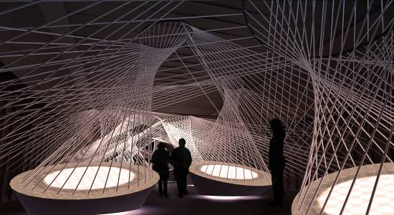

Caption 1: The "resonate" light art project supported by Zumtobel inspires visitors with a truly unique sound and lighting installation.

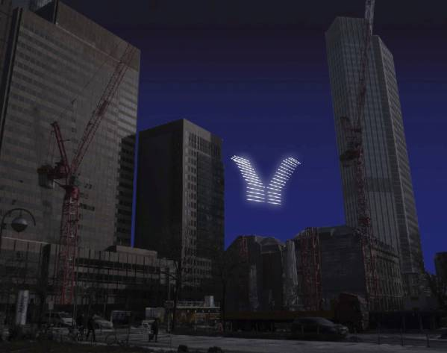

Caption 2: Although not yet completed, the TaunusTurm office building is already a work of art. For the Luminale, artist Laura Bernadet has delineated the future tower block head with white lines of light.

