Press release

Opening of Zumtobel's new Light Centre in Paris
From 18 June 2013, new lighting experiences will be presented at “La Lumière d’Uzès”

Paris, June 2013 – With the opening of the new Light Center “La Lumière d’Uzès” in the heart of Paris, a new member is added to the family of around 20 Zumtobel Light Centers and three Light Forums all over the world. The Zumtobel Architecture Team applied a great deal of sensitivity to create a world of lighting experience in the historical building, built in 1867, on Rue d’Uzès. Unmistakable is the purist design by Zumtobel, which has skilfully enhanced the historical building's charisma. The team managed to create not only a space of approx. 250 m² where light can show its versatility to full effect, but also an atmosphere that invites visitors to stay for a while. Situated right in the centre of Paris, Zumtobel is not just within easy reach, but also offers its partners and customers an inspiring meeting point and room for joint meetings, events and exhibitions.

The latest generation of LED luminaires demonstrate their skills
The focus is on presenting products based on cutting-edge LED technology that perfectly combine the potential to save energy with lighting comfort. Visitors will learn everything there is to know about the most recent products and will also be able to test them in various applications; individual models for specific projects can also be set up in these rooms.
A special feature of the showroom: natural daylight is deliberately used to create a pleasant room ambience. Moreover, this allows a direct comparison of the effects and quality of artificial lighting and daylight. For one of the highlights of the new showroom is the demonstration of the Tunable White technology, which makes it possible for the first time to create artificial lighting that has the quality of daylight. The visitors' attention is also attracted by a shop window installation and a small model of a museum. The entire wealth of options available to set goods and objects centre stage is authentically presented here to optimum effect.
By presenting a small “bouquinerie”, “La Lumière d’Uzès” makes a reference to Parisian culture as well. 20 award-winning Zumtobel annual reports are displayed in an exhibition modelled on a typical Parisian book stall, each of them a unique copy produced in cooperation with renowned artists and designers.

An attractive location
Austrian luminaire manufacturer Zumtobel has been operating its own sales organisation in France, Zumtobel Lumierè, since 1979. “The new offices and the Light Center on Rue d’Uzès, right in the heart of Paris, are an important step for us. They emphasise our presence on the French market, bringing us closer to our customers and partners,” says Bruno Touzery, Managing Director Zumtobel France, who is pleased about the new location. The central location combined with stylish design and a relaxed atmosphere make the new Light Center an attractive meeting place that can also be used by customers and partners for meetings and events.

Captions:
(Photo Credits: Zumtobel)
Picture 1: Its central location makes the new “La Lumière d’Uzès” Light Center easy to reach.
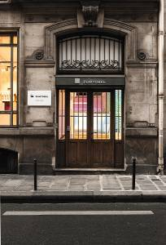
Picture 2: Unmistakable: the purist design by Zumtobel, which has enhanced the historical building's charisma.
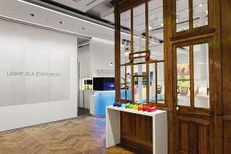
Picture 3: Visitors can authentically experience for themselves the entire wealth of options available to set goods and objects centre stage.

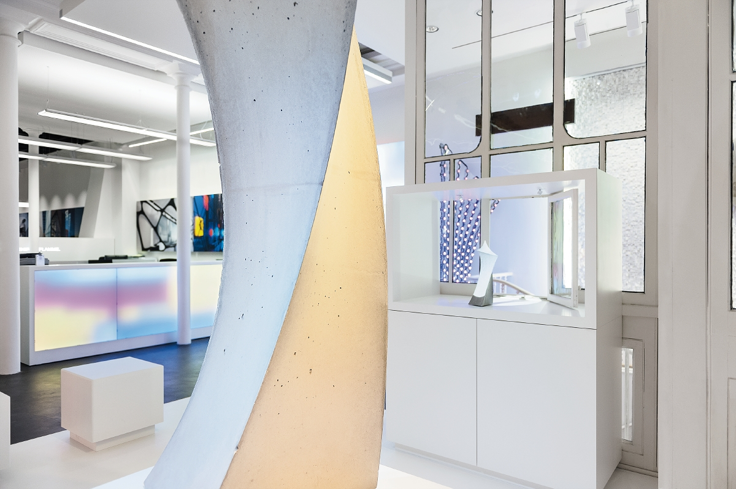

Brief profile
Zumtobel is a leading international supplier of integral lighting solutions that enable people to experience the interplay of light and architecture. As a leader in innovation, the luminaire manufacturer provides a comprehensive range of high-quality luminaires and lighting management systems for the most varied application areas of professional interior lighting – including offices and educational facilities, presentation and retail, hotels and wellness, health and care, art and culture as well as industry and engineering. Zumtobel is a brand of the Zumtobel group with its head office in Dornbirn, Vorarlberg (Austria).

For more information, please contact

  Zumtobel Lighting GmbH  Nikolaus Johannson  Head of Brand Communication  Schweizer Strasse 30  A-6850 Dornbirn  Tel. +43 -5572 -390-26427  Fax. +43-5572-390-926427  nikolaus.johannson@zumtobel.com  www.zumtobel.com | Zumtobel Lumière Sarl  Bruno Touzery  Managing Director France  10 rue d’ Uzès  F-75002 Paris  Tel.: +33 1 56 33 32 50  Fax : +33 1 56 33 32 59  info@zumtobel.fr  www.zumtobel.fr

Zumtobel. The Light.

