Press release

ARCOS: spotlight range providing a perfect art experience
Zumtobel adds the Arcos Xpert LED spotlight and the Arcos LED wallwasher to the Arcos luminaire range. With the Arcos spotlight family, David Chipperfield has created a range of luminaires that is synonymous with unobtrusive design and high lighting quality. With the new models, Zumtobel now offers an extensive portfolio for accent lighting in art galleries and museums that incorporates innovative LED technology and meets the highest conservational requirements thanks to UV and IR-free light.
Dornbirn, November 2013 – Thanks to innovative LED and reflector technology, the spotlight is able to exploit its full potential. Arcos Xpert cannot fail to impress in accent lighting on account of its high colour rendering index of Ra 94 and low colour tolerance (2-step MacAdam). Artworks and exhibits can thus be presented most authentically. The spotlight is optionally available in a warm (3000 K) or intermediate (4000 K) colour temperature. The tried-and-tested design of the Arcos spotlight has been left unchanged to allow gallery owners and museum curators to easily extend their existing luminaire portfolio by the spotlight's LED model.
The ARCOS Xpert spotlight is able to respond flexibly to a variety of lighting tasks with five different replaceable optics, four different lenses and two louvre designs to prevent direct glare. Pinpoint superspot light distribution is used to highlight even the smallest details. This high-precision lighting is made possible by a patented tapering dual reflector made of PC developed in-house. The reflector is specially matched to the LED module and, in combination with selected optics, produces excellent lighting quality perfectly appropriate for the exhibit to be illuminated. The LED remains invisible.
The spotlight can be dimmed both directly on the spotlight and via DALI. The cool touch function allows to handle the spotlight with bare hands also when it is switched on, for no heat is dissipated to the spotlight housing. Moreover, the LED's service life is considerably extended through passive cooling.
Linear wallwasher incorporating LED technology
In future, the Arcos LED wallwasher can be used to implement integral LED lighting solutions in art galleries and museums. The wallwasher's uncluttered design blends unobtrusively into the surrounding architecture. Thanks to a sophisticated optical solution and constant colour temperature of individual LEDs, the standard 620 mm version and the short 320 mm version of these dimmable linear wallwashers ensure uniform illumination of vertical surfaces. Zumtobel relies on top quality also in terms of materials: the housing is made of extruded aluminium section, the front sides of die-cast aluminium.
Both the Arcos LED wallwasher and the Arcos Xpert spotlight are optionally available in anthracite or white. The Arcos product range is Zumtobel's integral lighting solution for museums and art galleries that is based on efficient LED technology and allows the creation of superb centre-stage settings for art.
Facts & figures
ARCOS Xpert | Colour rendering > 90 Ra  Optionally 3,000 K or 4,000 K  Dimmable via DALI or via rotary potentiometer  Accessories (optional):  Replaceable reflector superspot 10°  Replaceable reflector spot 15°  Replaceable reflector flood 25°  Replaceable reflector wideflood 40°  Wallwasher attachment, anthracite  Wallwasher attachment, white  Oval outline lens 30°  Oval outline lens 50°  Oval outline lens 55 x 70°  Soft outline lens  Honeycomb mesh, black  Cross louvre, anthracite  Cross louvre, white  Barn doors, black  Filter holder
ARCOS LED wallwasher | 320 mm, 15 W, 900 lm  620 mm, 30 W, 1,800 lm  Optionally 3,000 K or 4,000 K  Dimmable via DALI or via rotary potentiometer
Captions:
(Photo credits: Zumtobel)
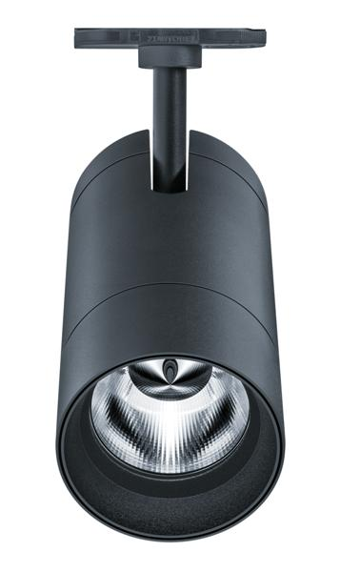
Caption 1: Arcos Xpert cannot fail to impress thanks to its high colour rendering index of Ra 94 and meets the highest conservational requirements.
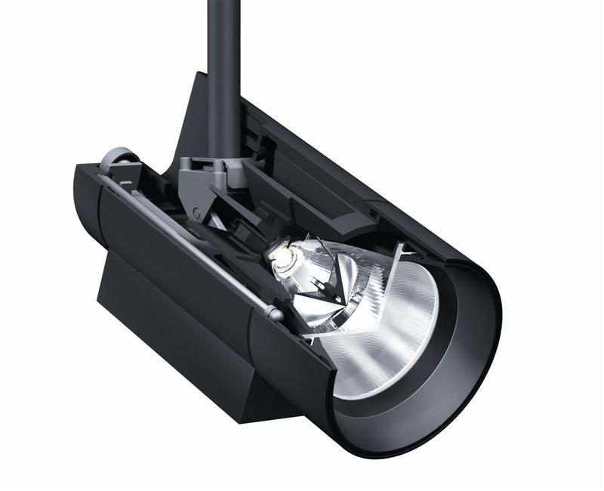
Caption 2: The superspot's tapering dual reflector allows for perfect accent lighting.
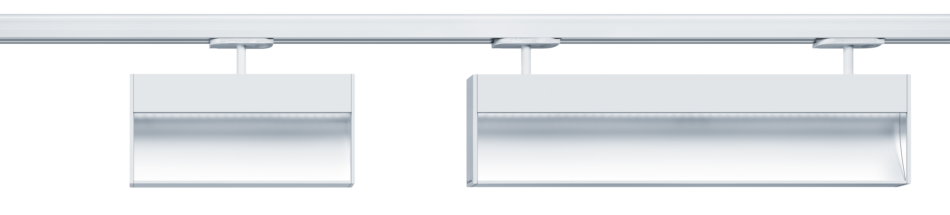
Caption 3: Linear LED wallwasher for uniform wide-area illumination.

For more information, please contact:
Zumtobel Lighting GmbH  Nikolaus Johannson  Head of Brand Communication  Schweizer Strasse 30  A-6851 Dornbirn  Phone: +43 (0) 5572 390-26427  Mobile: +43-(0)-664-80892-3202  E-mail: nikolaus.johannson@zumtobel.com  www.zumtobel.com | Zumtobel Lighting GmbH  Sophie Moser  PR Manager  Schweizer Strasse 30  A-6851 Dornbirn  Phone: +43-5572-390-26527  Mobile: +43-664-80892-3074  E-mail: sophie.moser@zumtobel.com  www.zumtobel.com

About Zumtobel
Zumtobel is a leading international supplier of integral lighting solutions that enable people to experience the interplay of light and architecture. As a leader in innovation, the luminaire manufacturer provides a comprehensive range of high-quality luminaires and lighting management systems for the most varied application areas of professional interior lighting – including offices and educational facilities, presentation and retail, hotels and wellness, health and care, art and culture as well as industry and engineering. Zumtobel is a brand of Zumtobel AG with its head office in Dornbirn, Vorarlberg (Austria).

Zumtobel. The Light.

