Press release

Customised lighting for modern office environments
LIGHT FIELDS evolution LED luminaire range featuring Tunable White technology

The LIGHT FIELDS evolution Tunable White LED luminaires comply with the clear and uniform stylistic idiom of the award-winning product range, steering it towards a user-friendly future thanks to profound application know-how and technological innovations. LIGHT FIELDS evolution with Tunable White technology is Zumtobel's answer to the users' need for adaptive light that can be customised. With a colour rendering index of Ra 80, the LED luminaire range can be dimmed continuously between 3000 K and 6000 K.
Dornbirn, March 2014 – Contemporary office environments feature flexible workstation design and are based on the individual needs of office users. Team workstations, conference islands, tablet or PC work: for a wide range of applications, users need not only ideal lighting conditions but also a lighting system that can be adjusted to meet their specific needs. Tunable White stands for intelligent adjustment of colour temperature to changing room situations and room utilisation. The whole luminaire range can be continuously dimmed by the user between warm white (3000 K) and cool (6000 K) colour temperatures, allowing to implement a perfect lighting situation at the workstation. This is made possible by integrating special Tridonic Tunable White LED modules together with a matching converter.
Tunable White also allows for adjustment to changes based on the time of day and the season: depending on requirements, the luminaire can be adjusted to match the currently prevailing conditions. By adding Tunable White technology to the luminaire range, Zumtobel now offers a customisable lighting solution that can be adjusted to personal preferences and tasks and at the same time reduces complexity for the designers.
Innovative technology providing perfect lighting quality
No matter whether you work at a computer, use a tablet, attend a meeting or hold a presentation: the LED luminaire range will always provide perfect lighting quality without producing any glare. This is made possible by the patented micro-pyramidal optic (MPO+). The diffuser layer of the optic uniformly resolves the LED points, preventing annoying reflections on displays. Even at high luminous flux levels, luminance is consistently reduced, providing pleasantly distributed light even at steep radiation angles.
In addition, innovative technologies have been incorporated in the various luminaire models. For the recessed, surface-mounted and wall-mounted luminaires, Zumtobel has developed the 3Dprotect® reflector. Its 3D structure protects the LED modules during installation, preventing damage from electrostatic discharge. At the same time, the structure's reflection factor ensures an increase in the luminaire efficiency level. In the free-standing and pendant luminaires, the dot matrix based on litePrint® light guide technology ensures uniform light distribution.
Award-winning design
The Light Fields evolution LED luminaire range combines a clear stylistic idiom with technological innovation. Thanks to their uniformly slim-line design, low mounting height and high-grade, light-weight materials, the luminaires blend perfectly into contemporary office interiors. For these features, the LED luminaire range has won the iF product design award 2014.
Light Fields evolution Tunable White will be available from autumn 2014. From 30 March until 4 April 2014, Zumtobel will present the innovative luminaire range at light+building, in hall 2.0 at stand B30+B31.

Captions: (Photo credits: Zumtobel)
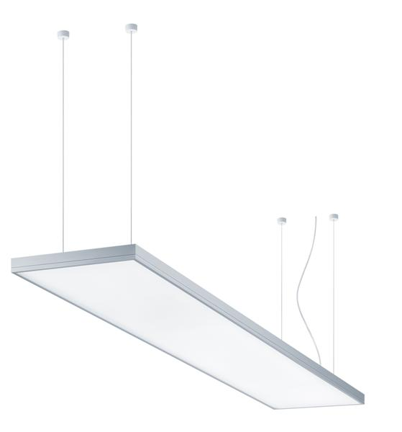
Caption 1: Light Fields evolution combines a clear stylistic idiom with technological innovation, providing a complete LED luminaire range for integral office lighting.

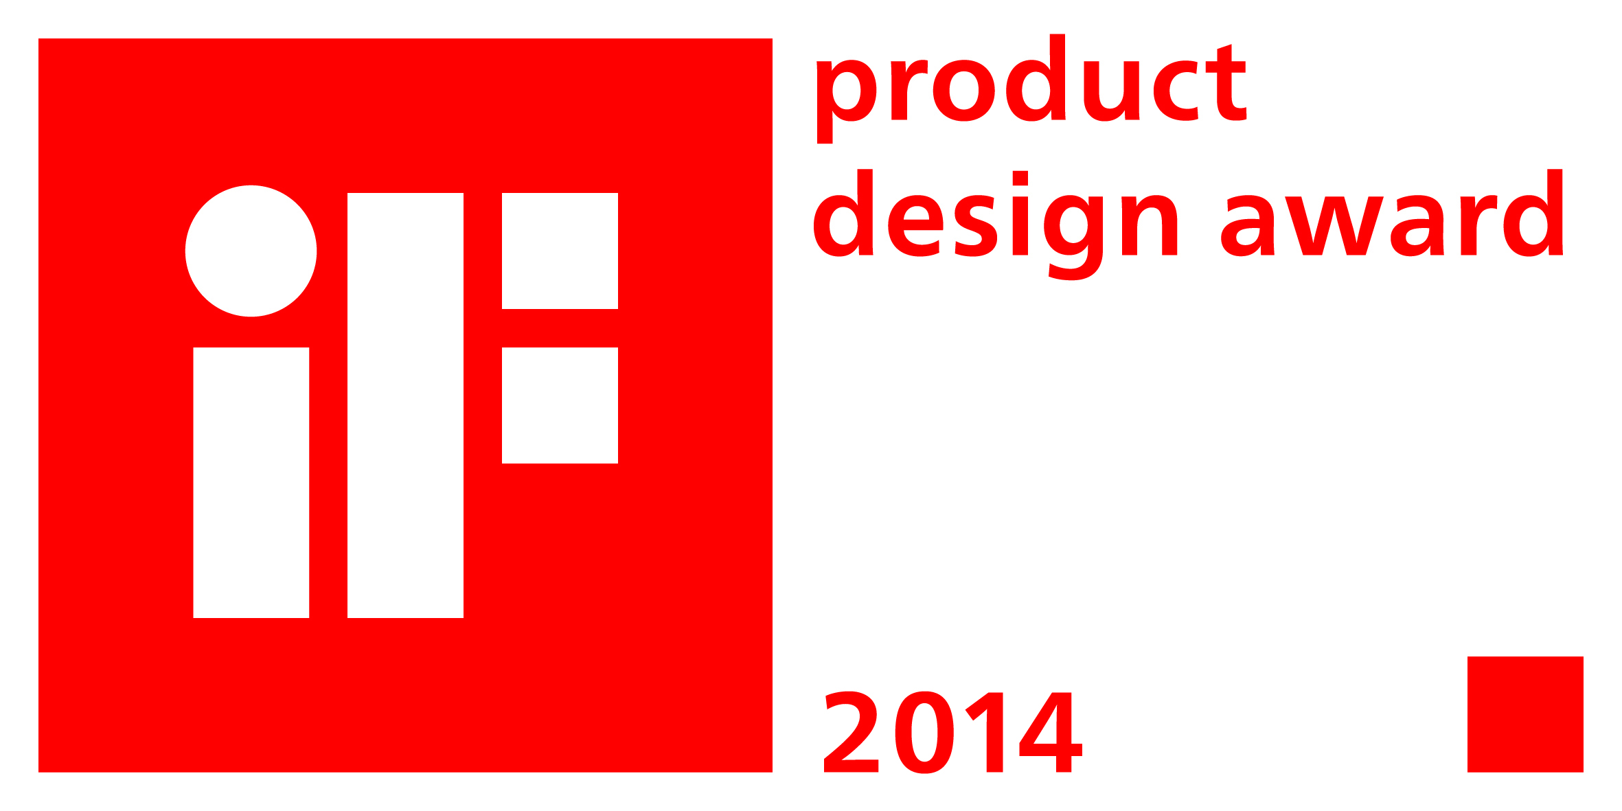
Caption 2: On account of its clear design, the LED luminaire range has won the iF product design award 2014.

Press contact:
Zumtobel Lighting GmbH
Sophie Moser
PR Manager
Schweizer Strasse 30
A-6851 Dornbirn

Tel +43-5572-390-26527
Mobile +43-664-80892-3074
E-mail sophie.moser@zumtobel.com

www.zumtobel.com
Sales Germany, Austria, Switzerland
Zumtobel Licht GmbH  Grevenmarschstr. 74-78  32657 Lemgo  Germany  Tel.: +49-5261-212-7445  Fax: +49-5261-212-817445  E-mail: info@zumtobel.de  www.zumtobel.de | Zumtobel Licht GmbH  Donau-City-Strasse 1  1220 Vienna  Austria  Tel.: +43-1-258-2601-0  Fax: +43-1-258-2601-82845  E-mail: welcome@zumtobel.at  www.zumtobel.at
Zumtobel Licht AG
Thurgauerstrasse 39
8050 Zurich
Switzerland
Tel.: +41-44-30535-35
Fax: +41 44 305 35 36
E-mail: info@zumtobel.ch
www.zumtobel.ch

About Zumtobel
Zumtobel, a leading international supplier of integral lighting solutions, enables people to experience the interplay of light and architecture. As a leader in innovation, Zumtobel provides a comprehensive range of high-quality luminaires and lighting management systems for professional interior lighting in the areas of offices, education, retail, hotel & wellness, health, art & culture as well as industry. Zumtobel is a brand of Zumtobel AG with its head office in Dornbirn, Vorarlberg (Austria).
Zumtobel. The Light.

