Press release

Above standard – Zumtobel's emergency lighting for buildings
Thanks to useful design tools and an extended product range, Zumtobel's ONLITE RESCLITE is able to provide safety to every building. The emergency luminaires do not only meet all relevant standards, but are also maintenance-free, efficient and capable of blending into the interior, even under difficult conditions and in rooms with high ceilings.
Dornbirn, June 2014 – Safety in buildings is a matter of course. In a sphere so tightly controlled by legal standards, you would hardly think that there is room for individual design. In particular when it comes to application areas with increased safety standards or high ceilings, conventional lighting technology concepts soon reach their limits. Zumtobel's ONLITE RESCLITE high ceiling (HC) emergency luminaire is a powerful solution for high ceilings such as those mostly found in industrial bays, warehouses and shopping centres. RESCLITE HC can be installed in rooms with ceiling heights of up to 23 m (RESCLITE escape) or up to 30 m (RESCLITE antipanic) and offers all benefits of the classic RESCLITE luminaire range, such as virtually no maintenance, high energy efficiency and maximum spacing between luminaires thanks to optimised optics.
ONLITE RESCLITE HC is available in two models in compliance with EN 1838: as RESCLITE escape, for illuminating escape routes, and as RESCLITE antipanic, for room orientation in emergencies. The newly developed special lens of RESCLITE escape focusses the light along a lengthy, narrow strip. Thanks to high-performance LED modules and optimised optics, luminaire spacings of up to 22 metres can be achieved and the required minimum illuminance of one lux is ensured without any problems. Thus, energy-efficient illumination of escape routes in conformity with relevant standards is ensured.
On the other hand, antipanic lighting must achieve an illuminance level of at least 0.5 lux in order to provide orientation and allow people to safely find their way out of the building. Thanks to wide-angle and rotationally symmetrical light distribution, already one RESCLITE antipanic high ceiling luminaire is sufficient to uniformly illuminate an area of up to 290 square metres (at a mounting height of 16 m). With a high protection rating of IP65, the luminaires are protected against dust and water jets from any angle and hence also perfectly suited for use in harsh industrial environments. The luminaire can be installed directly on the ceiling or integrated into the TECTON continuous-row lighting system. It can be combined with the central CPS and eBox emergency lighting systems, which are available with DALI (NDA), Powerline (NSI) and circuit monitoring (NPS).

Additional support for emergency lighting designers
Zumtobel is also extending the services offered to emergency lighting designers. Not only is it possible to download the popular Zumtobel ONLITE RESCLITE app from the iTunes store, it is now also available on the Zumtobel website. Thus, access to the design tool is now possible from every PC, laptop, tablet or smartphone using any browser, independent of the device's operating system. On iPads and iPhones, the app can even be used offline and has become a valuable tool for emergency lighting designers. In just a few steps, the RESCLITE app is able to calculate the maximum spacing between emergency luminaires, depending on the mounting height.
Those who use mobile devices featuring different operating systems or laptops may download the tool from the Zumtobel homepage on the data sheet of every RESCLITE luminaire under the “Spacing” tab. There the mounting height of the luminaire can be adjusted by means of a slider. Subsequently, the maximum spacing between two luminaires is displayed.

Link to iTunes store
Link to the ONLITE RESCLITE product portfolio on the homepage

Captions:
(Photo credits: Zumtobel)
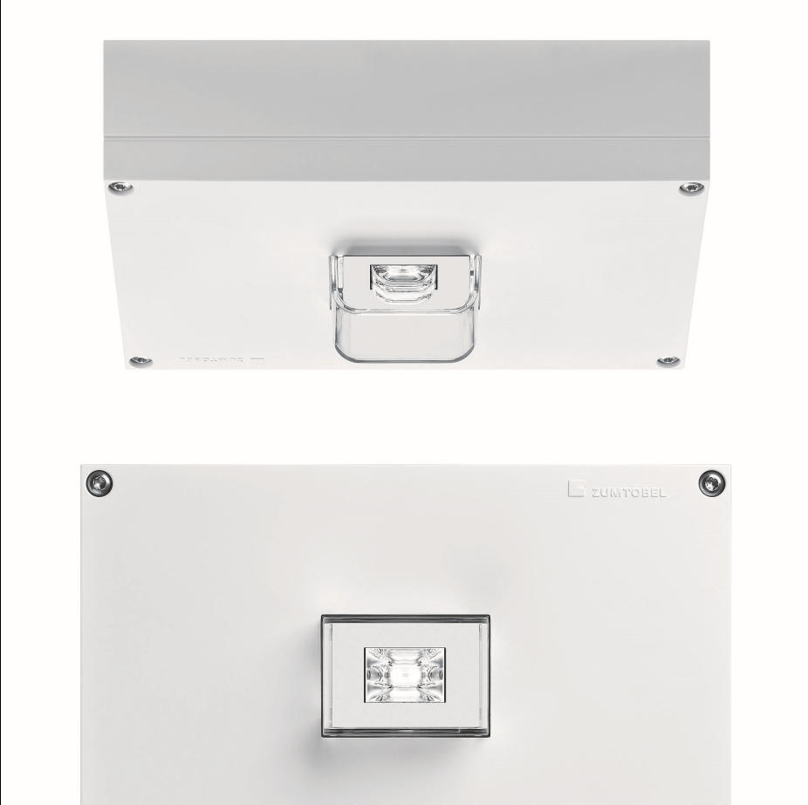
Caption 1: Zumtobel's ONLITE RESCLITE high ceiling (HC) emergency luminaire is a powerful solution for high ceilings such as those mostly found in industrial bays, warehouses and shopping centres. RESCLITE HC escape can be used for ceiling heights of up to 23 m.
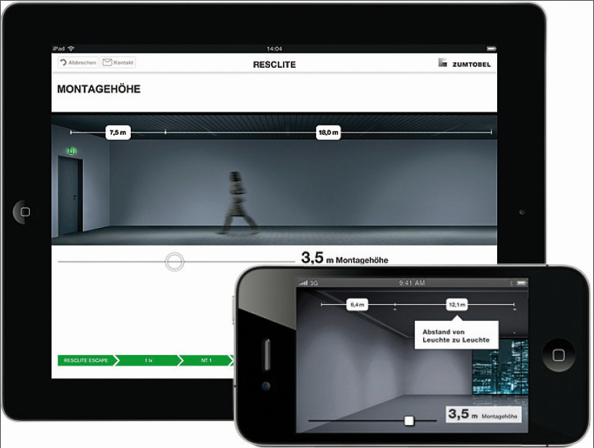
Caption 2: Not only is it possible to download the Zumtobel ONLITE RESCLITE app from the iTunes store, it is now also available on the Zumtobel website.

Press contact:
Zumtobel Lighting GmbH
Sophie Moser
PR Manager
Schweizer Strasse 30
A-6851 Dornbirn

Tel: +43-5572-390-26527
Mobile: +43-664-80892-3074
E-mail: sophie.moser@zumtobel.com

www.zumtobel.com
About Zumtobel
Zumtobel, a leading international supplier of integral lighting solutions, enables people to experience the interplay of light and architecture. As a leader in innovation, Zumtobel provides a comprehensive range of high-quality luminaires and lighting management systems for professional interior lighting in the areas of offices, education, presentation & retail, hotel & wellness, health, art & culture as well as industry. Zumtobel is a brand of Zumtobel AG with its head office in Dornbirn, Vorarlberg (Austria).
Zumtobel. The Light.

