Press release

Lighting ensures unique shopping experience
Zumtobel provides integral LED lighting solution for new Spar flagship store

For the new market hall of the Spar retail chain in Budapest, Zumtobel has implemented an efficient LED lighting concept for presenting the goods to optimum effect while creating an appealing ambience that makes customers feel at ease and encourages them to buy.

Dornbirn, May 2014 – The new flagship store of the Spar retail chain situated at Budapest's “MOM-Park” is a market hall with a sophisticated architectural design where the emphasis is to provide customers with a unique shopping experience. With this goal in mind, the Budapest-based architects' studio LAB5 developed a wave-shaped wooden ceiling structure for the 2000 m² supermarket that merges with the wall shelving, accentuating the spacious open-plan room structure. The wood creates a pleasant natural atmosphere that makes customers feel at ease. The store layout is characterised by free-standing retail islands and counters, where customers can explore the goods displayed and obtain advice. The walkways have been designed so that customers who are in a hurry can proceed directly to the POS terminals via so-called “to-go counters” situated at the entrance. In addition, large counters manned by sales staff are situated along an extended route through the market for shoppers who are willing spend more time. The aim of this concept is to increase customer satisfaction. A significant part of the unique shopping experience in the Spar flagship store is due to the lighting, which not only sets the stage for optimum presentation of the goods, but also creates an inviting ambience that makes customers stay and feel at ease. In close coordination with the architects, Zumtobel has implemented an efficient LED lighting solution that completely blends into the interior and ensures optimum presentation of the products using accent lighting.

Visual highlighting of individual product groups ensures attractive product presentation and makes it easier for shoppers to find their way within the store. Moreover, the freshness of the food displayed is emphasised by targeted use of specific colour spectrums. For illuminating the fresh food department and the wine racks, Zumtobel has opted for efficient high-performance LED spotlights: swivelling VIVO LED “Tunable Food” spotlights and CARDAN “Tunable Food” recessed luminaires provide high-precision accent lighting in order to present sensitive foodstuffs such as meat and fish to optimum effect. Zumtobel's “Tunable Food” LED concept allows product-specific illumination and effective presentation of goods. Thanks to innovative technology, the perfect colour temperature can be adjusted directly at the spotlight, with ten colour settings already pre-programmed. This ensures an authentic look of the products with perfectly uniform light distribution. Furthermore, IR- and UV-free lighting provided by LED luminaires is gentle on fresh food and reduces harmful thermal output, ensuing that fruit and vegetables remain luscious and meats stay fresh longer.
Baked goods, the wines on offer and the cheese counter are presented to optimum effect by the VIVO LED and CARDAN LED spotlights featuring built-in “Stable White” technology in a colour temperature of 3000 K. The market hall's uniform ambient lighting is provided by TECTON, a flexible continuous-row LED system integrating batten luminaires, light sources and reflectors within its trunking. This allows for easy installation and reduces maintenance costs. TECTON has been mainly installed as individual light ribbons in the wooden ceiling and between the shelves, which allows the luminaires to blend decoratively into the interior, underlining the character of the room.
Another benefit of the LED lighting solution fitted at the Spar market in Budapest is its high energy-saving potential. By using LED luminaires, at least 40 percent of energy can be saved, as compared to a conventional luminaire system. In addition, LED luminaires by Zumtobel boast a service life of at least 50,000 hours – the LED lighting solution therefore requires virtually no maintenance.

Facts & figures on the Zumtobel products used
VIVO LED | LED spotlight for accent lighting; swivelling spotlight; excellent colour rendering, choice of perfect light colour and glare control; luminous flux: up to 4210 lm; colour temperature: 3000 K or 4200 K; IR- and UV-free light
CARDAN LED | Ceiling-recessed LED luminaire for accent lighting; patented reflector/lens system allows high-precision beam patterns; passive cooling of lighting head for gentle illumination; dimmable; luminous flux: 1700 lm; colour rendering: RA > 90; UVA- and IR-free lighting; lighting head swivels through 30 degrees
TECTON LED | Continuous-row LED system with trunking, integrating power supply, lighting control and connection to emergency lighting; four different optics; perfect light control; optionally with daylight-based control, presence detection or movement sensors; luminaire efficiency up to 104 lm/W; colour temperature: 3000 K and 4000 K; colour rendering: Ra>80

Captions:

(Photo credits: Zumtobel)
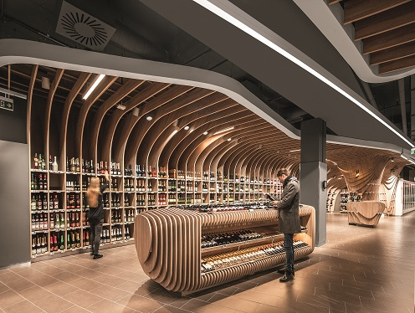
Caption 1: The Budapest-based architects' studio LAB5 developed a wave-shaped wooden ceiling structure for the 2000 m² supermarket that merges with the wall shelving, enhancing the spacious open-plan room structure.

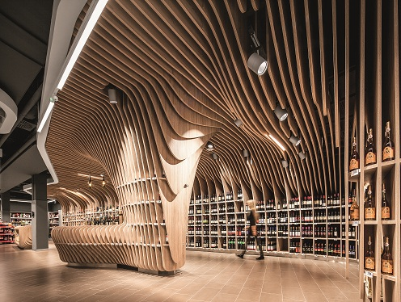

Caption 2: For illuminating the wine racks, Zumtobel has opted for efficient high-performance LED spotlights: swivelling VIVO LED spotlights presenting the products to optimum effect are unobtrusively built into the wooden ceiling structure.

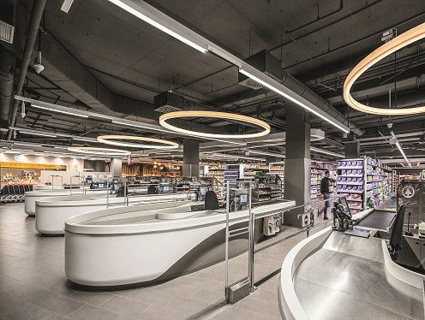

Caption 3: Uniform ambient lighting – as shown here above the POS terminals – is provided by TECTON, a flexible continuous-row LED system integrating batten luminaires, light sources and reflectors within its trunking.

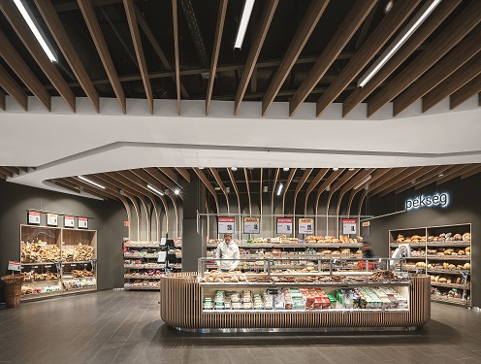
Caption 4: Baked goods are presented to optimum effect by the VIVO LED and CARDAN LED spotlights featuring built-in “Stable White” technology in a colour temperature of 3000 K.

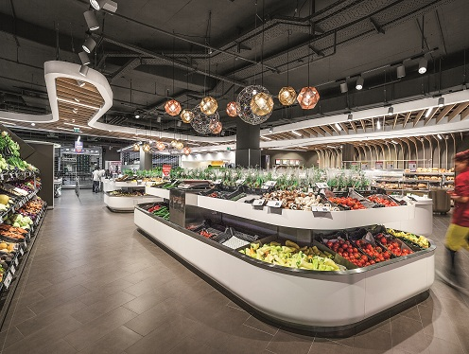
Caption 5: VIVO LED Tunable Food spotlights provide targeted, yet gentle illumination of fruit and vegetables.

For more information, please contact:
Zumtobel Lighting GmbH  Sophie Moser  PR Manager  Schweizer Strasse 30  A-6850 Dornbirn  Tel +43-5572-390-26527  Mobil +43-664-80892-3074  E-Mail sophie.moser@zumtobel.com  www.zumtobel.com | Zumtobel Lighting Kft  Váci út 49  1134 Budapest  Hungary  www.zumtobel.hu

About Zumtobel
Zumtobel, a leading international supplier of integral lighting solutions, enables people to experience the interplay of light and architecture. As a leader in innovation, Zumtobel provides a comprehensive range of high-quality luminaires and lighting management systems for professional interior lighting in the areas of offices, education, retail, hotel & wellness, health, art & culture as well as industry. Zumtobel is a brand of Zumtobel AG with its head office in Dornbirn, Vorarlberg (Austria).

Zumtobel. The Light.

