Press release

Zumtobel at the Biennale Architettura 2014
Innovative special lighting solutions for two major contributions

Dornbirn, 6 June 2014 - The Biennale Architettura 2014 in Venice, curated by Rem Koolhaas, will open its doors on 07 June 2014. Until 23 November 2014, pioneering architectural ideas and concepts will be presented in the city with its lagoons and islands under the title of “fundamentals”. This year again, Zumtobel is involved as a sponsor, supporting two art projects by providing advice and lighting solutions developed specifically for this purpose. The Austrian lighting solutions provider has been a partner for central projects in the context of the most important exhibition of contemporary architecture since 2002.
“By supporting the Biennale di Venezia, Zumtobel makes a valuable and creative contribution to the discourse of light, architecture and art,” says Stefan von Terzi, Director Marketing at Zumtobel. “Our lighting solutions in the German Pavilion and the Central Pavilion also show how important it is to provide the right light for the installations and the architecture to present them to optimum effect.”

Fast motion presentation using LED
Koolhaas' motto of the exhibition in the Central Pavilion is “Elements of Architecture”, putting the focus on the fundamental components of a building such as the ceiling and the stairs. In order to enhance the experience and encourage discussion, Zumtobel has developed and implemented an integral lighting concept for the impressive domed area located at the centre of the pavilion. The main feature is a special LED solution that sets the ceiling fresco by the Italian painter Galileo Chini in the dome centre stage using various colour temperatures (TunableWhite technology). The installation, which is concealed behind a sill and integrated in a suspended ceiling at the same time, simulates the natural course of daylight. By means of various colour temperatures ranging from warm (3000K) to cool (7000K), the ceiling fresco is provided with fascinating aesthetic qualities, highlighting the polarity between nature and built-up space .

Zumtobel sets the stage for architecture installation in German Pavilion
For the exhibitions of the 29 National Pavilions at the Biennale, Koolhaas has made “Absorbing Modernity: 1914-2014” the overriding theme and has requested the countries to revert to their national architecture of the past 100 years. This year's curators of the German Pavilion, the Swiss-based German architects Alex Lehnerer and Savvas Ciriacidis, have responded to this request through an accessible room-to-room installation called “BUNGALOW GERMANIA”. This is an architectural assembly of two buildings historically significant to Germans: the first is the German Pavilion in Venice itself, built in 1912, converted in 1938 and 1964. The second building is the Chancellor's Bungalow in Bonn by Sep Ruf, built in 1964. These two buildings represent two eras in German history, two political systems and two architectural idioms.
The installation by architects Lehnerer and Ciriacidis is a 1:1 replica of parts of the Bungalow integrating the architecture of the Pavilion. A “third room” is eventually created that links the histories, moments, eras and locations of the two buildings, allowing for new associations in terms of form and use of architecture and the related German history. The unique architecture of this project is enhanced by a special lighting solution provided by Zumtobel, strongly emphasising the concept of the two artists.

For more information on the Biennale, please visit www.labiennale.org

Captions:
(Photo Credits: François Halard)
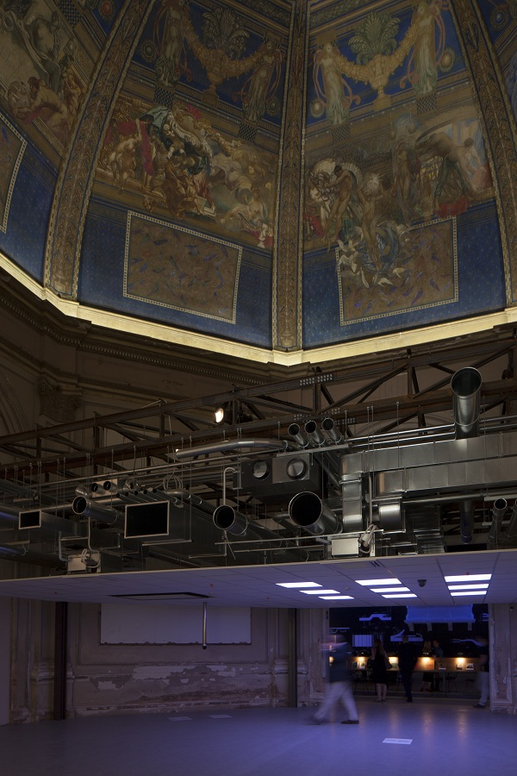
Caption 1: International Pavilion. The main feature is a special LED solution that sets the ceiling fresco by the Italian painter Galileo Chini in the dome centre stage using various colour temperatures (TunableWhite technology).

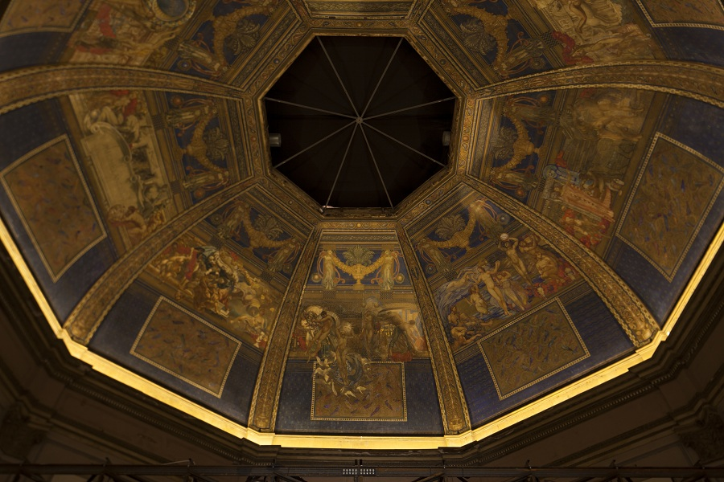

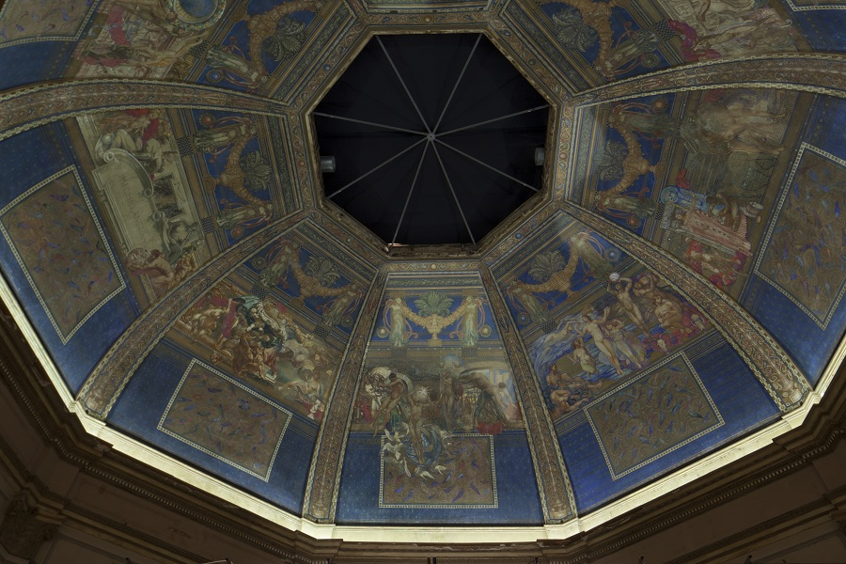

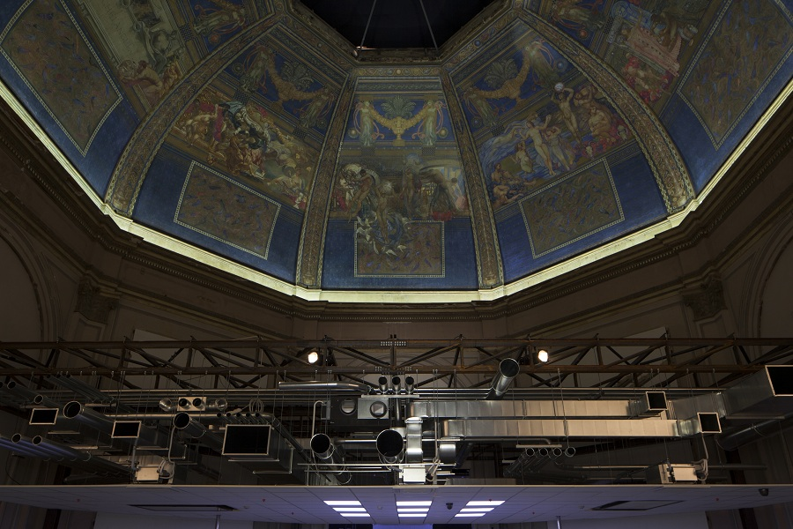
Caption 2/3/4: Change of colour temperature at the international Pavilion.

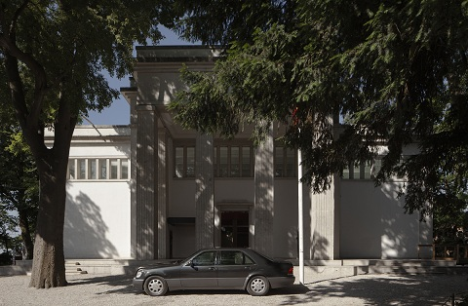
Caption 5: External view of Bungalow Germania, Ciriacidis Lehnerer
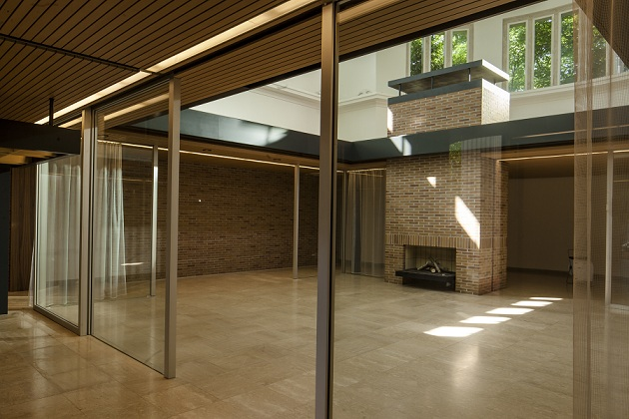
Caption 6: Interior view Bungalow Germania, Ciriacidis Lehnerer
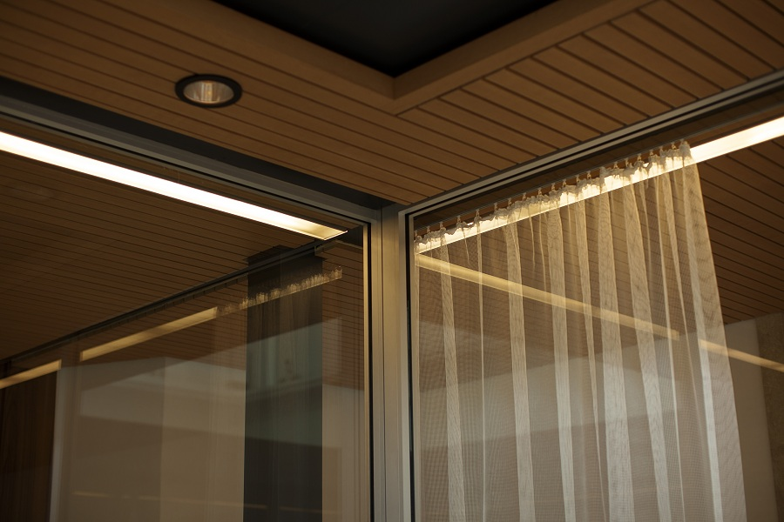
Caption 7: Zumtobel lighting solution at the german pavilion
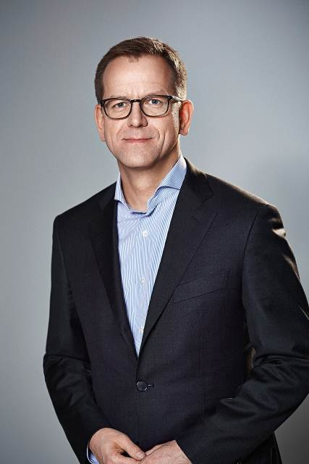
Caption 8: Stefan von Terzi, Director Marketing Zumtobel

For more information, please contact:
Zumtobel Lighting GmbH
Sophie Moser
PR Manager
Schweizer Strasse 30
A-6850 Dornbirn
Tel +43-5572-390-26527
Mobil +43-664-80892-3074
E-Mail sophie.moser@zumtobelgroup.com
www.zumtobel.com

About Zumtobel
Zumtobel, a leading international supplier of integral lighting solutions, enables people to experience the interplay of light and architecture. As a leader in innovation, Zumtobel provides a comprehensive range of high-quality luminaires and lighting management systems for professional interior lighting in the areas of offices, education, retail, hotel & wellness, health, art & culture as well as industry. Zumtobel is a brand of Zumtobel AG with its head office in Dornbirn, Vorarlberg (Austria).

Zumtobel. The Light.

