Press release

Unobtrusive elegance
Maison Ullens designer label illuminated by Zumtobel Light

On the catwalk as well as in the design of its first flagship store in Paris, the French fashion label “Maison Ullens” has found its own way, showing a good measure of individualism. Equally personalised and customised is the lighting solution provided by Zumtobel. The right light creates the appropriate ambience to meet the customers' demands in the various areas of the boutique.
Dornbirn, June 2014 – OMA, the international architects' studio based in Rotterdam, was commissioned with developing the design concept for the first “Maison Ullens” boutique in Paris. David Gianotten, one of OMA's partners, and project architect Inge Goudsmit worked in close collaboration with the founder of the label, Myriam Ullens. The result is a perfect mix of OMA's contemporary architectural style and the brand philosophy of Maison Ullens.

Although the boutique conveys unobtrusive elegance and restraint, the products are presented in a dramatic setting, also thanks to an ivory-coloured wall made of onyx marble that divides the store into two areas. In the spaces open to the public, the brand world of Maison Ullens is brought to life. Materials such as wood, marble, leather, brass and terrazzo are not only a reference to French history and craftsmanship, but also present subtle contrasts to the latest fashion designs. The changing rooms provide cocoon-like areas of retreat that create a warm and private atmosphere for customers to enjoy the shopping experience. In the entire boutique, PANOS infinity downlights and CARDAN LED spotlights provide for uniform and pleasant LED ambient lighting. Here and there, accents are created by the modular MICROTOOLS lighting system.

The lighting solution supports this concept mainly through the lighting effect, while the luminaires themselves remain discreetly in the background. The minimalist yet powerful VIVO XS LED spotlight system has been installed on tracks in the ceiling and is particularly restrained thanks to its miniaturised design. After all, the aim is to present the latest fashion items in the right light effectively and with unobtrusive elegance. Thanks to excellent colour rendering of Ra>90, the high-quality fabrics are set centre-stage authentically and gently by the LED-only lighting solution. However, the elegant materials used in the interior design, too, are enhanced to optimum effect by appropriate lighting. The SUPERSYSTEM E1 lighting system complements the lighting solution installed at Maison Ullens in Paris.
Captions:
(Photo credits: Zumtobel)
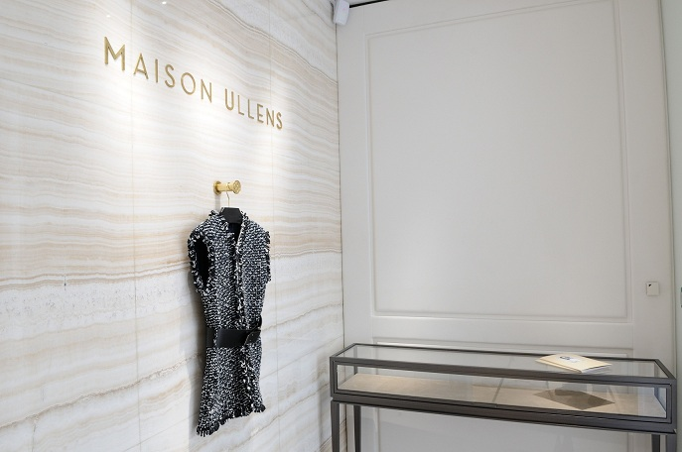
Caption 1: Zumtobel has developed a custom-made LED lighting concept for the Maison Ullens label in Paris

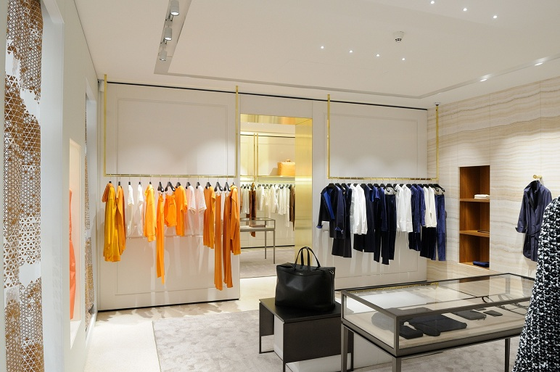
Caption 2: The VIVO XS LED spotlight cannot fail to impress thanks to its excellent colour rendering, brilliant light and minimalist design.

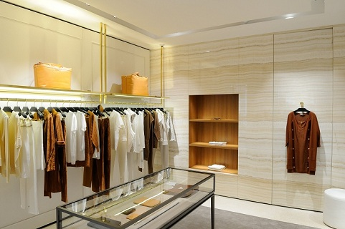
Caption 3: The lighting solution enhances the store concept mainly through the lighting effect achieved, while the luminaires themselves remain discreetly in the background.

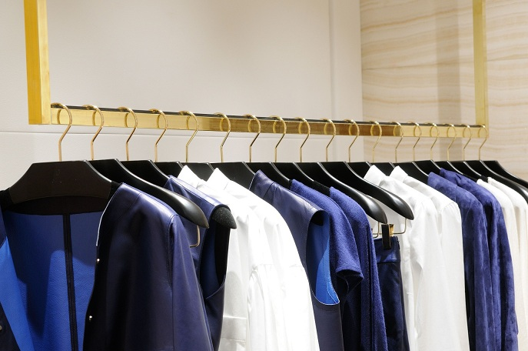
Caption 4: Thanks to excellent colour rendering of Ra>90, the high-quality fabrics are set centre-stage authentically and gently by the LED-only lighting solution.

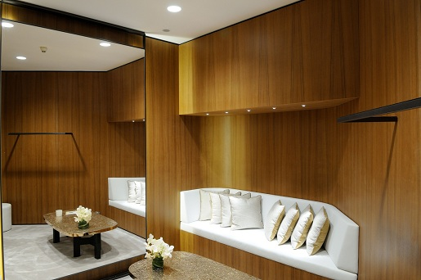

Caption 5: The changing rooms provide cocoon-like areas of retreat that create a warm and private atmosphere for customers to enjoy the shopping experience. PANOS Infinity downlights and MICROTOOLS have been installed here.

For more information, please contact:
Zumtobel Lighting GmbH
Sophie Moser
PR Manager
Schweizer Strasse 30
A-6850 Dornbirn
Tel +43-5572-390-26527
Mobil +43-664-80892-3074
E-Mail sophie.moser@zumtobelgroup.com

www.zumtobel.com

About Zumtobel
Zumtobel, a leading international supplier of integral lighting solutions, enables people to experience the interplay of light and architecture. As a leader in innovation, Zumtobel provides a comprehensive range of high-quality luminaires and lighting management systems for professional interior lighting in the areas of offices, education, retail, hotel & wellness, health, art & culture as well as industry. Zumtobel is a brand of Zumtobel AG with its head office in Dornbirn, Vorarlberg (Austria).

Zumtobel. The Light.

